NHS App toolkit – NHS partners
Promoting use of NHS App and enabling notifications (v1 4/09/26)
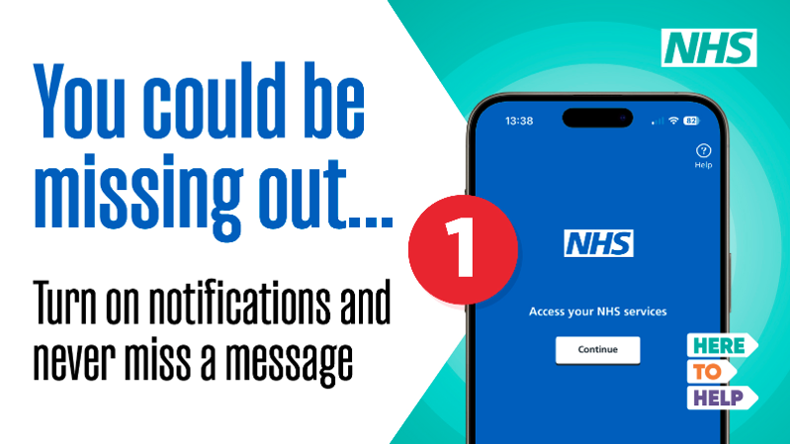
The North East and North Cumbria Integrated Care Board (ICB) has developed the 'NHS App' toolkit to support NHS partners, to promote the use of the NHS App.
The campaign aims to help patients access the right care by making better use of the NHS App.
We are asking for help to raise awareness of what the App can do, to encourage more patients to download and use it, particularly in areas where uptake is low, and remind patients to turn on notifications so they can receive important messages and updates about their care.
The toolkit is designed for sharing across social media and other communication channels.
You can download the online digital toolkit here: NHS App toolkit
Your support in helping us to share these messages is very much appreciated.
For further help or advice on using the toolkit or if you need support to tailor assets, please contact either: Alastair Railton alastair.railton2@nhs.net or Abbie Mulgrew abbie.mulgrew@nhs.net

The NHS App communication toolkit includes:
- Key messages
- Content you can add to your website
- Copy of the ICB's press release promoting the campaign (for information)
- Messages, graphics and videos to add to your social media channels
- Additional assets including information and adverts to add to digital screens

Key messages for patients
What is the NHS App?
The NHS App is a simple and secure way to access NHS services and manage your healthcare online.
You can use it on your smartphone or tablet.
Depending on the services available from your GP practice and hospital, you can use the NHS App to:
- order repeat prescriptions and choose which pharmacy you want to collect them from
- book, change or cancel GP and hospital appointments
- view test results and other information in your health record
- view your medicines, vaccinations, health conditions and documents
- view and manage some hospital referrals
- receive messages and updates from your GP practice, hospital and other NHS services
- contact your GP practice about a health problem or make an admin request, where this service is available
- check and book some vaccinations
- manage NHS services for a child or someone else you care for, where you have permission to do so.
Some services are not available to everyone and will depend on your GP practice, hospital or local NHS services.
Using the NHS App can save you time and help you manage your healthcare when it suits you, without always needing to call or visit your GP practice.
Don't miss important NHS messages
Your GP practice, hospital or another NHS service may send you important information through the NHS App. This could include information about your care, appointments, test results or something you need to do.
Turn on notifications for the NHS App so you know when you have a new message. Please check and read NHS App messages as soon as possible after receiving a notification.
If you have problems using the NHS App, help and support is available through the App and on the NHS website. You can also contact your GP practice if you need help with a service provided by them.

Website copy

Use the NHS App to manage your healthcare
The NHS App is a safe and easy way to use NHS services on your phone or tablet. It can help you manage your healthcare at a time that suits you, without always needing to call or visit your GP practice.
With the NHS App you can:
- order repeat prescriptions and choose a pharmacy to collect them from
- view your GP health record, including test results and vaccination information
- book, change or cancel GP appointments, where available
- view and manage hospital appointments and referrals, where available
- receive messages from your GP practice, hospital and other NHS services
- contact your GP practice about a health problem or make an admin request, where available.
The services you can use may depend on your GP practice, hospital or local NHS service.
Find out more about the NHS App, including how to set it up and get help using it, on the NHS website.
Check your NHS App messages
Your GP practice, hospital or another NHS service may send you important information through the NHS App. This could include appointment updates, test results, information about your care or something you need to do.
Please check and read your messages as soon as possible after you receive a notification, so you do not miss important information about your care.
Turn on notifications
Turn on notifications for the NHS App so you know when you have a new message. This will help you see important updates when they arrive.
Need help?
If you need help using the NHS App, including accessing your account or finding your messages, visit the NHS website for NHS App help and support. If your question is about information or a service provided by your GP practice, please contact the practice directly.

Press release (for information)

Tap the App - Region's NHS urges thousands to download the NHS App and turn on notifications
THOUSANDS of people are being urged to download the NHS App to make sure they don't miss important messages about their care.
The NHS, across the North East and North Cumbria, has launched a new Tap the App campaign with a simple message: download the App, switch on notifications and check your messages when they arrive.
Around seven in ten people across much of the region have already downloaded the NHS App, but uptake is much lower in some areas, where only around four in ten people are using the App with notifications switched on.
The NHS App gives people a quick and secure way to manage their healthcare from their smartphone or tablet.
People can use the App to order repeat prescriptions, view health records and test results, manage appointments and referrals, and receive messages from their GP practice, hospital and other NHS services. Some services depend on what is available locally.
Dr Neil O'Brien, chief medical officer, NHS North East and North Cumbria Integrated Care Board and practising GP, said: “We all lead busy lives, so anything that makes managing our healthcare a little easier can help.
“Downloading the NHS App and turning on notifications means you'll know when there's a new message about your care. It could be an appointment update, a test result or something your NHS team needs you to do.
“It takes seconds to check your notifications are on – and it could mean you don't miss something important.”
Messages sent through the NHS App can include appointment updates, test results or information about care.
Rebecca McIntosh, head of digital transformation, NHS North East and North Cumbria Integrated Care Board (ICB), added: “The NHS App puts more of your healthcare at your fingertips.
“If you haven't downloaded it yet, we'd encourage you to give it a try. And if you already have it, take a minute to check your notifications are switched on.
“That way, when your GP practice or hospital sends you a message, you'll know it's there and can check it straight away.”
The Tap the App campaign is asking people across the North East and North Cumbria to:
Download it. Switch on notifications. Check your messages.
The NHS App is free to download from the Apple App Store and Google Play. NHS App services can also be accessed online through the NHS website.
For more information and help using the NHS App, visit www.nhsapp.service.nhs.uk/login.

Social media
Please tag us in your social media posts – download all assets on our online toolkit
Use #HereToHelp
Facebook - NorthEastandNorthCumbriaNHS
X – @NENC_NHS
Instagram – nenc_nhs
TikTok - @nenc_icb
LinkedIn - @north-east-and-north-cumbria-nhs
YouTube - North East and North Cumbria NHS

Social media plan –
 | Facebook/Instagram | X | Graphic and video
1. | 📱Save time with the NHS App  The NHS App makes it easy to manage your healthcare from your phone or tablet.  You can:  ✔️ Order repeat prescriptions  ✔️ View your health record (where available)  ✔️ Manage appointments (where available)  ✔️ Receive messages from your GP practice or hospital  Download the NHS App and manage your health at a time that suits you.  #TaptheApp #HereToHelp | 📱Save time with the NHS App  Order repeat prescriptions, view your health record, manage appointments and receive messages from your GP practice or hospital – all from your phone or tablet.  Download the NHS App and manage your health when it suits you.  #TapTheApp #HereToHelp | 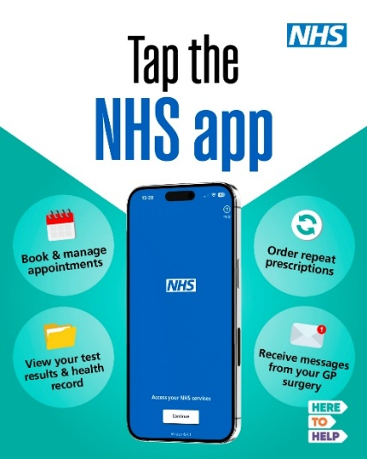  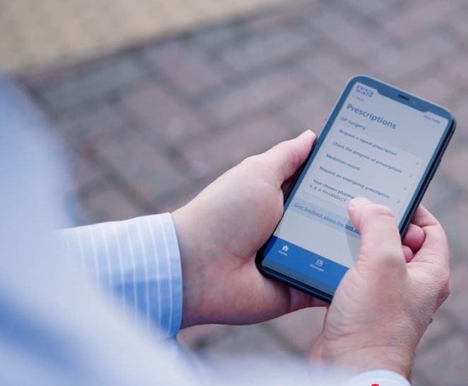  https://youtu.be/wBHRYnb_TWA (27 seconds)
2. | 📱Save time with the NHS App  The NHS App makes it easy to manage your healthcare without calling your GP practice or hospital.  You can use the NHS App to:  - Order repeat prescriptions  - Manage GP appointments (where available)  - View test results and your health record (where available)  - Receive messages from your GP practice or hospital  Download the NHS App today and manage your healthcare at a time that suits you.  #TaptheApp #HeretoHelp | 📱Save time with the NHS App – without calling your GP practice or hospital.  Order repeat prescriptions, manage appointments, view test results and your health record and receive messages.  Download the NHS App today.  #TapTheApp #HereToHelp | 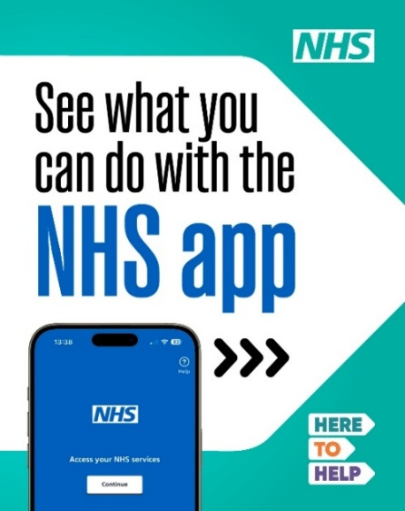  (Carousel)  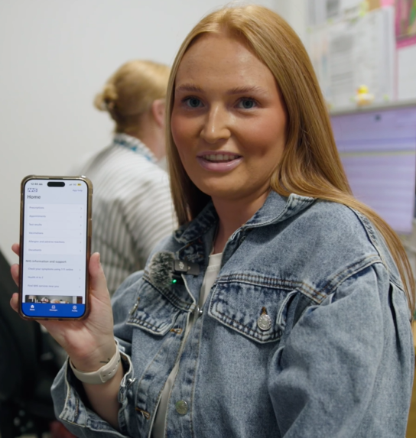  https://youtu.be/cpdA8_3a508 (24 seconds)
3. | 📱Don't miss important updates  Your GP practice or hospital may send you important messages through the NHS App, including appointment updates, test results and information about your care.  Turn on notifications and check your messages within 24 hours so you don't miss anything important.  #TaptheApp #HereToHelp | 📱Don’t miss important updates from your GP practice or hospital.  The NHS App can send you messages about appointments, test results and your care.  Turn on notifications and check your messages within 24 hours so you don’t miss anything important.  #TapTheApp #HereToHelp | 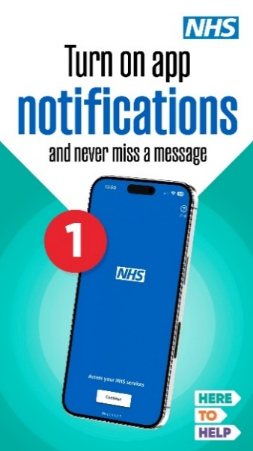  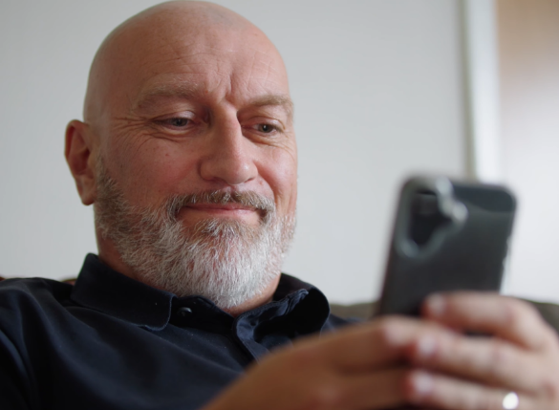  https://youtu.be/yNoqBZGcs1M (28 seconds)
4. | The NHS App gives you quick, secure access to NHS services wherever you are.  Order repeat prescriptions, view test results, check referrals and receive messages from your GP practice or hospital, all in one place.  📱Download the NHS App today, turn on notifications and stay up to date with important messages.  #TaptheApp #HereToHelp | 📱The NHS App gives you quick, secure access to NHS services wherever you are.  Order repeat prescriptions, view test results, check referrals and receive GP practice or hospital messages – all in one place.  Download the NHS App and turn on notifications.  #TapTheApp #HereToHelp | 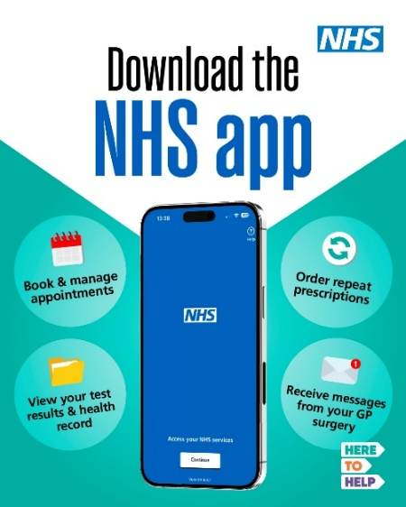  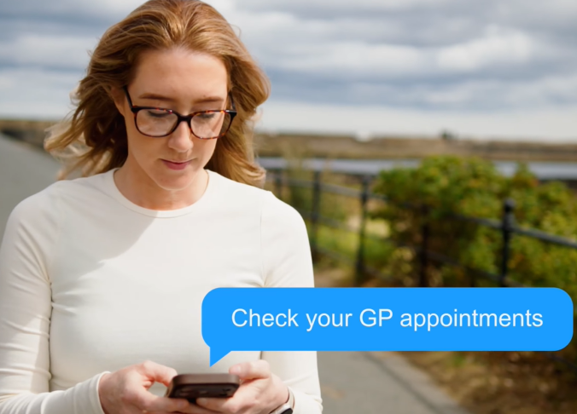  https://youtu.be/_vf_KlytpcU (19 seconds)
5. | It only takes a few minutes to download the NHS App and turn on notifications!  📱With notifications switched on, you'll receive important messages and updates from NHS services directly to your phone, helping you stay on top of your healthcare.  Download the NHS App today.  #TaptheApp #HereToHelp | 📱It only takes a few minutes to download the NHS App and turn on notifications.  With notifications on, you’ll receive important messages and updates from NHS services directly to your phone, helping you stay on top of your healthcare.  #TapTheApp #HereToHelp | 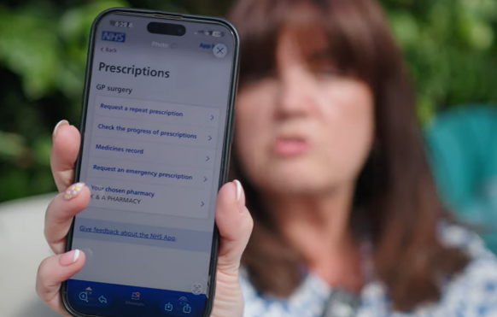  https://youtu.be/MJpCxe1-tsM (21 seconds)

Additional assets for use on digital screens
Digital screen | 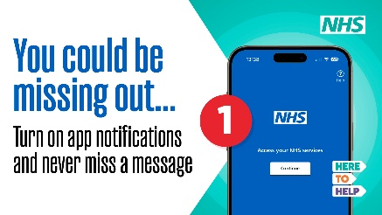 | Digital ads | 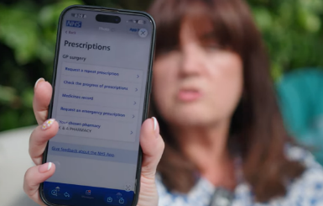
TV ad | 