

Welcome to the latest edition of Cumbria, Northumberland, Tyne and Wear NHS Foundation Trust (CNTW) newsletter. This edition brings you the latest news and developments from across the Trust - from improvements in patient care to the achievements of our staff, and the ongoing work with our partners and communities.
Thank you for your continued interest and support.

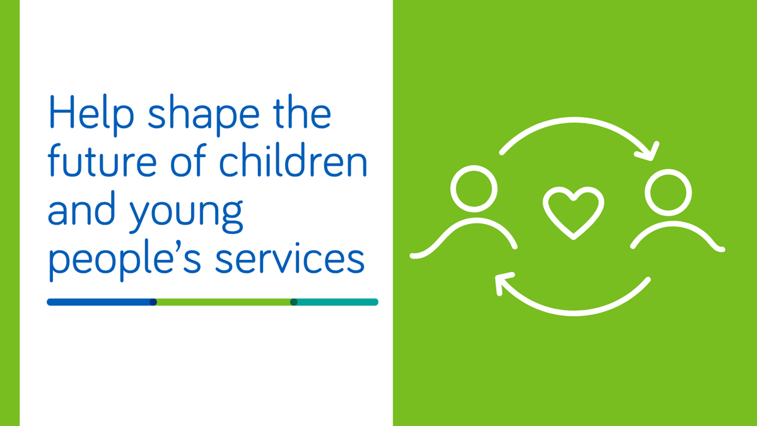

We're inviting children and young people, families, carers, staff, partner organisations and local communities to help shape the future of mental health services for children and young people.
We know that children, young people and families have different needs. While some may benefit from specialist hospital care, others may need support closer to home. By sharing your experiences of current services, what is working well and where improvements could be made, you can help us understand what matters most when intensive mental health support is needed.
No decisions have been made about future services. This listening programme is about hearing a wide range of views and experiences before considering whether any changes may be needed. The feedback we receive will help us understand the needs of children, young people and families and will inform any future plans.
We would particularly like to hear views on:
- What matters most to children, young people and families when accessing intensive mental health support.
- What works well in current services and where improvements could be made.
- The support that should be available in local communities and closer to home.
- What is most important when hospital care is needed.
- Barriers that can make it harder for some children, young people and families to access support.
- What a high-quality, safe and compassionate service should look like in the future.
We are committed to listening carefully to the experiences and ideas shared with us. We will use what we hear, alongside service information, evidence and national guidance, to help inform future decisions about children and young people's intensive mental health services.
We'd love to hear your views. There are several ways to get involved, including attending an engagement event or completing a questionnaire.

  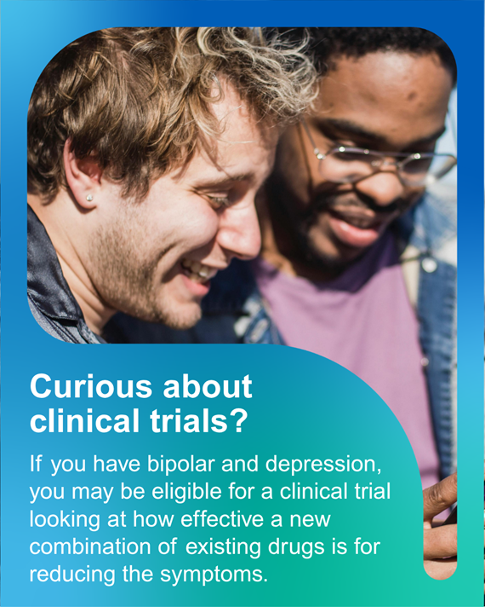
  Take part in research to improve treatment for bipolar depression
  The NIHR-funded ASCEnD Trial is seeking participants from across the North East and North Cumbria to help researchers understand whether a combination of aripiprazole and sertraline can improve outcomes for people experiencing bipolar depression.
  

  
  Join us at our Annual Celebration Event
  Join us on Thursday 24 September for a day of celebration, learning and networking at St Nicholas Hospital, Newcastle.
  Explore marketplace stalls and refreshments from 10am to 12pm, then from 1pm to 3pm hear how teams across the Trust are improving care, supporting people and making a real difference.
  📍 Jubilee Theatre, St Nicholas Hospital, Gosforth, Newcastle upon Tyne, NE3 3XT.
  Can't make it in person? Contact us below for joining details.
  

Work for us

We have a number of posts available across a range of specialities across Cumbria, Northumberland, Tyne and Wear.





 |  |  |  |  |  |  |  | 

Cumbria, Northumberland, Tyne and Wear NHS Foundation Trust St. Nicholas Hospital, Jubilee Road, Gosforth, Newcastle Upon Tyne, NE3 3XT.
Unsubscribe.

