Welcome to the latest edition of Cumbria, Northumberland, Tyne and Wear NHS Foundation Trust (CNTW) newsletter. This edition brings you the latest news and developments from across the Trust - from improvements in patient care to the achievements of our staff, and the ongoing work with our partners and communities.
Thank you for your continued interest and support.



Have your say on the future of our older people’s inpatient organic services

We have launched an engagement process, seeking people’s views on how and where we provide inpatient care for older adults with organic mental health needs. (These are issues caused by physical changes in the brain. For example, dementia, Alzheimer’s, and delirium.)
This work is part of our Service Change Plan 2026-27: Delivering tomorrow, with you in mind. It supports our strategy.
We are exploring several possible ways to meet people's needs in the future. There are benefits and challenges for each of these scenarios, so we want to hear your views. (We might also consider other opportunities and scenarios, based on what we hear from people during these engagement periods.) The main focus of this review will be how we use Roker, Mowbray and Woodhorn wards in future.
We are keen to hear from you, our partners across the system.
We also want to hear from patients, carers and families. Please share this information with people via your own newsletters and other communication channels, and encourage them to have their say.
People can come along to an engagement event (in person or online) – the events are listed on our Older Adult inpatient services engagement webpage.
Or they can fill out a short online survey. This survey is open until 25 September 2026.
Visit our website to read more about this engagement process.

  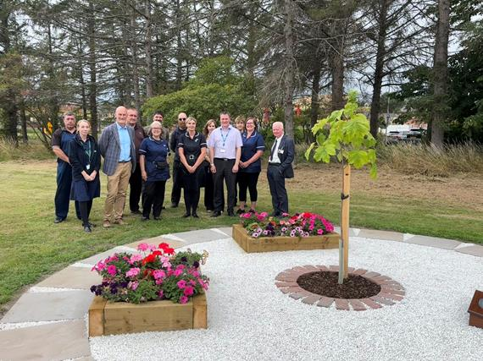
  New Sycamore garden opens at Northgate Hospital
  Patients, staff and partners came together to celebrate a new outdoor space at Sycamore Unit, Northgate Hospital. Built around the unit's Sycamore Gap sapling, the area was improved with support from housing specialist Lovell. It gives patients, staff and visitors a peaceful place to enjoy nature, relax and spend time together.
  

  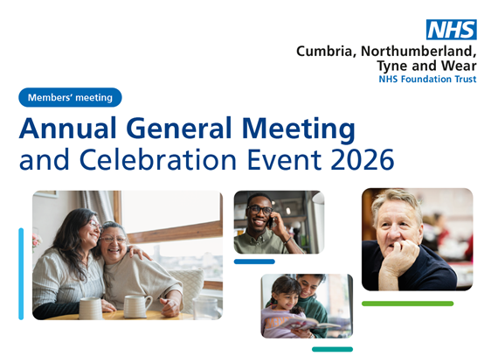
  Join us at our Annual Celebration Event
  Join us on Thursday 24 September for a day of celebration, learning and networking at St Nicholas Hospital, Newcastle.
  Explore marketplace stalls and refreshments from 10am to 12pm, then from 1pm to 3pm hear how teams across the Trust are improving care, supporting people and making a real difference.
  📍 Jubilee Theatre, St Nicholas Hospital, Gosforth, Newcastle upon Tyne, NE3 3XT.
  Can't make it in person? Contact us below for joining details.
  

Work for us

We have a number of posts available across a range of specialities across Cumbria, Northumberland, Tyne and Wear.





 |  |  |  |  |  |  |  | 

Cumbria, Northumberland, Tyne and Wear NHS Foundation Trust St. Nicholas Hospital, Jubilee Road, Gosforth, Newcastle Upon Tyne, NE3 3XT.
Unsubscribe.

