Staff wellbeing hub
Communications toolkit
The staff wellbeing hub is a free and confidential support service for anyone working or volunteering in health and social care across the North East and North Cumbria.
It’s designed to help staff look after their mental health and wellbeing, especially when dealing with pressures at work or at home. The aim is to help staff get support early, prevent problems getting worse and support people to stay well and in work.
This toolkit has been designed to help organisations promote the wellbeing hub offer internally to their teams within health and care sector.

What the hub offers
The hub gives you quick access to support from trained professionals:
- Talk to a mental health professional – you’ll get a one-to-one appointment to discuss what’s going on
- Short-term support sessions – usually up to three follow-up sessions after your first appointment
- Signposting to other services – if you need more or longer-term help, they guide you to the right place
This support is designed to be quick, compassionate, and easy to access, often with fast appointments and no long waiting lists

How it works
- You can self-refer
- It’s confidential, meaning your employer isn’t informed
- Most appointments are done by phone or video, so it’s flexible around your work
- The team aims to get back to you within one working day
What kind of support it covers
The hub can help with a wide range of issues, including:
- Stress or burnout
- Anxiety or low mood
- Work pressures
- Personal or home-related challenges
It also connects you with wider support options if needed, such as therapy or specialist services.

Newsletter/bulletin copy (this copy can also be used on intranets)
Working or volunteering in the NHS, social care or similar voluntary sector organisations can be demanding. If things feel tough, whether that is at work or home, you don't have to deal with it on your own.
The North East and North Cumbria staff wellbeing hub offers free, confidential support for anyone working in health or social care across our region.
The hub provides quick access to one-to-one support from an experienced mental health professional, along with up to three short follow-up sessions if needed. It can also help you find other services if you need longer-term support. You can talk about anything affecting your wellbeing, from stress and burnout to personal challenges.
Using the hub is simple and flexible. You can refer yourself and your employer will not be informed. Most appointments are carried out by phone or video, making it easier to fit around work and home life and you will usually hear back within a working day.
To access support, you can complete the online form, email hubstheword@cntw.nhs.uk, or call 0191 223 2030. Appointments will be arranged at a time that suits you.
We care for the people who care.

Download the assets
All assets for the Staff wellbeing hub are available to download from the North East and North Cumbria Integrated Care Board (ICB) resources page.
Download here: Staff wellbeing hub
We are asking colleagues and partners across the region to help us promote the wellbeing hub. By working together, we know that our messages are stronger and can reach more health and social care staff, which means more people get the support they need.
Assets available in the toolkit:
- Social media graphics
- Videos
- Posters and leaflets

Social media
Facebook – NorthEastandNorthCumbriaNHS
X - @NENC_NHS
Instagram - nenc_nhs
TikTok - @nenc_icb
LinkedIn - @north-east-and-north-cumbria-nhsYouTube - North East and North Cumbria NHS

Post | Copy | Artwork
General | Looking after others starts with looking after yourself. The North East and North Cumbria staff wellbeing hub offers free, confidential support for health and social care staff and volunteers. Self-refer today and speak to a mental health professional when you need it most.  Self-refer now: https://northeastnorthcumbria.nhs.uk/here-to-help-you/health-advice-and-support/staff-wellbeing-hub/ | 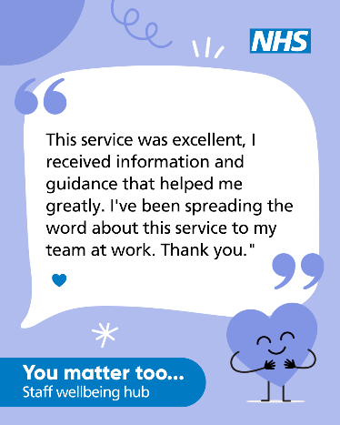  Download here: https://northeastnorthcumbria.nhs.uk/toolkits/staff-wellbeing-hub-toolkit/
General | Feeling stressed, overwhelmed or burnt out? The staff wellbeing hub provides free, confidential support for health and social care staff and volunteers across the North East and North Cumbria. Fast access, flexible appointments and no need to go through your employer.  Self-refer now: https://northeastnorthcumbria.nhs.uk/here-to-help-you/health-advice-and-support/staff-wellbeing-hub/ | 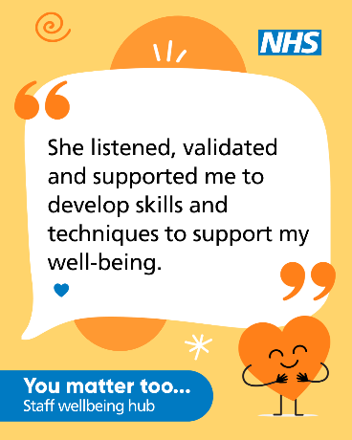  Download here: https://northeastnorthcumbria.nhs.uk/toolkits/staff-wellbeing-hub-toolkit/
General | If you’re feeling stressed, burnt out, anxious or low, the staff wellbeing hub offers free, confidential support for all health and social care staff and volunteers across the North East and North Cumbria.  Support is quick to access and designed to help before problems grow.  👉 Find out more:  https://northeastnorthcumbria.nhs.uk/here-to-help-you/health-advice-and-support/staff-wellbeing-hub/ |   Link to film: https://www.youtube.com/watch?v=-OYbufRdjGE  Download here: https://northeastnorthcumbria.nhs.uk/toolkits/staff-wellbeing-hub-toolkit/
Voluntary staff | If you work in the voluntary, community or social enterprise sector, the North East and North Cumbria staff wellbeing hub is here for you too. Free, confidential support for stress, anxiety, burnout and more. Self-refer today and speak to an experienced mental health professional.  👉 Find out more:  https://northeastnorthcumbria.nhs.uk/here-to-help-you/health-advice-and-support/staff-wellbeing-hub/ |   Link to film: https://youtu.be/-MdISMO9KJQ  Download here: https://northeastnorthcumbria.nhs.uk/toolkits/staff-wellbeing-hub-toolkit/
Smoke Free | Thousands of health and social care staff want to stop smoking but finding the time can be tough. That’s why all NHS and Social Care staff across @NENC_NHS can access FREE stop smoking support.  Visit https://smokefreeapp.com/referral-nhs/ to sign up. | 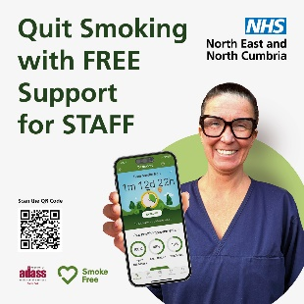  Download here: https://northeastnorthcumbria.nhs.uk/toolkits/staff-wellbeing-hub-toolkit/

