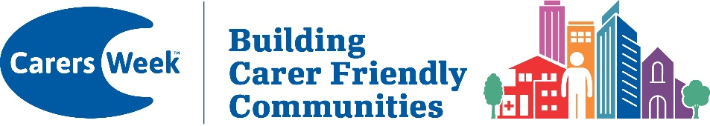

The theme for Carers Week 2026 is ‘Building Carer Friendly Communities’, Highlighting the power of building Carer friendly communities and the difference they can make to Carers lives. Carer friendly communities are places, spaces, services and community groups where unpaid carers are recognised, understood, and valued.

To our great partners in Furness and Ulverston,
Carer Support Furness would like to invite you to have a stand to showcase the amazing support and services you provide at our annual

FREE HEALTH AND
WELLBEING INFORMATION EVENT

On FRIDAY 12TH JUNE 2026 10.30am – 12.30pm

at CARER SUPPORT FURNESS, HINDPOOL COMMUNITY CENTRE,
BARROW-IN-FURNESS. LA14 1NF

There will be café style seating in the hall for FREE tea, coffee, refreshments and pie and peas (until they run out!).

To book an information stand please email admin@carersupportfurness.co.uk as soon as possible with details of your organisation, who will be attending, e.g. Name, contact details (email and phone no.) and any requirements.

