

BSI Guidance Suicide Prevention and the Workplace

The new British Standard guidance (BS 30480) highlights the growing importance of suicide prevention and postvention in the workplace.
Increasingly, employers are recognising the value of having a clear, dedicated strategy for suicide prevention and response — including support following an employee suicide — alongside their wider mental health and wellbeing initiatives.

Every Life Matters supports organisations of all sizes to take practical steps towards becoming suicide-safer workplaces. This includes access to toolkits, training programmes, and a range of evidence-based resources designed to help build awareness, confidence, and effective support pathways. For more information and a copy of our guidance to implementing the BSI standards please contact Juliet on Juliet.Gray@every-life-matters.org.uk

Read the BSI guidance here

Mental Health Awareness in the Workplace

We’re proud to introduce our new half-day Mental Health in the Workplace training, designed in response to the growing need for a more flexible, time-efficient option for busy workplaces.

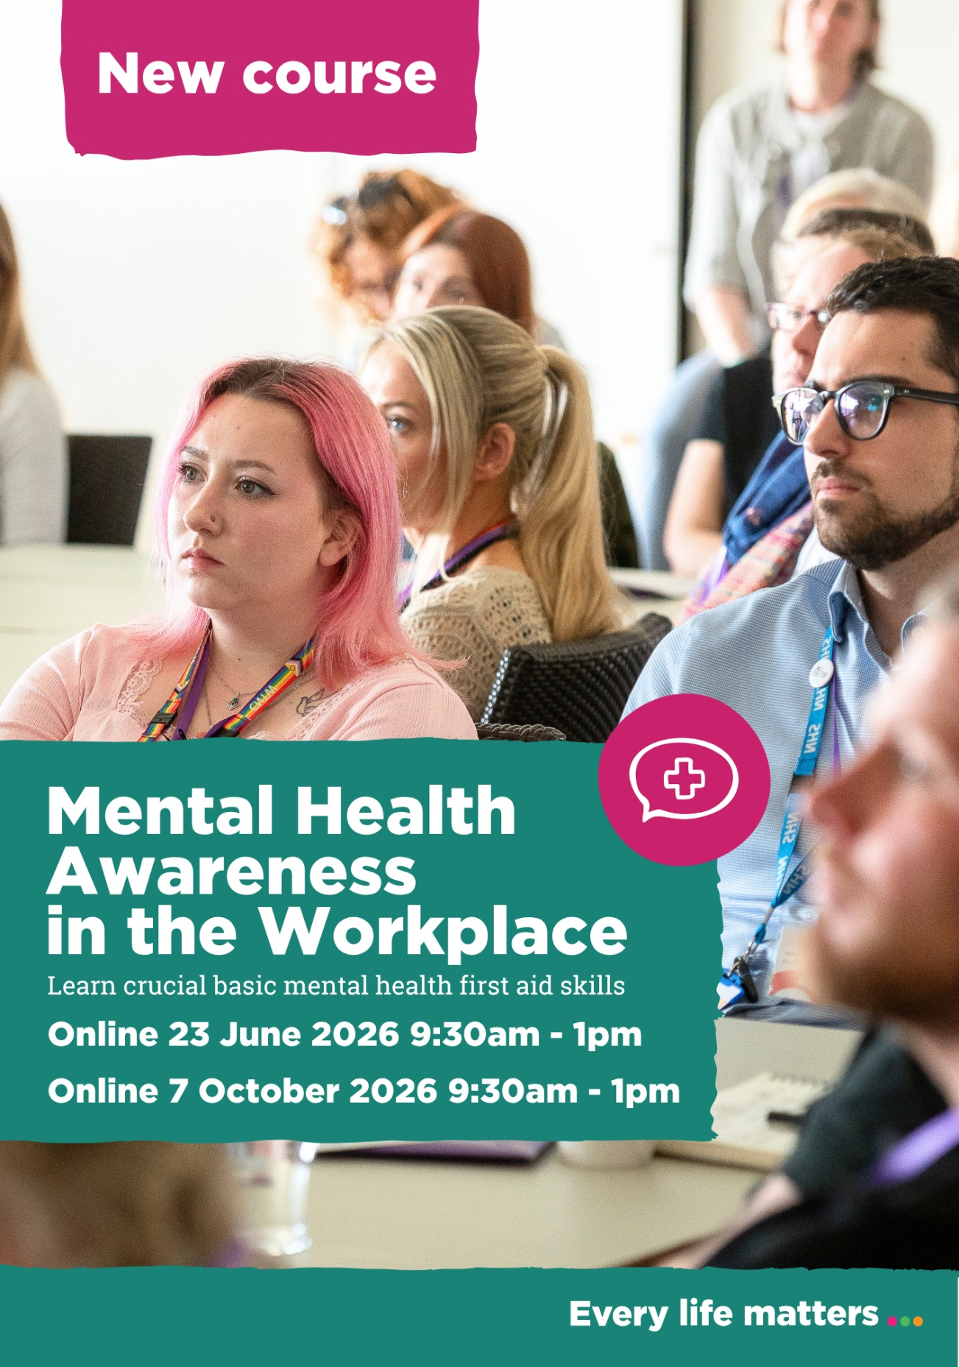

Investing in mental health training creates a healthier, safer, and more productive workplace. When managers can recognise early signs of distress and respond confidently, issues are addressed sooner—reducing absence, boosting retention, and strengthening team morale. Build a supportive culture where people can thrive.

The session is ideal for:

Line managers
Supervisors
People managers
Anyone wanting to better understand mental health and wellbeing in the workplace

3.5-hour interactive awareness session
Online: £45 per person
In-house session (8–24 people): £750

Session dates:
23rd June & 7th October 9:30- 1pm

Book an online session or arrange tailored in-house training for your organisation.

For more information contact us at: training@every-life-matters.org.uk

Take me to book my space!

Mental Health First Aid training

We are running both a face-to- face and online session of our Mental Health First Aid course which is fully accredited by MHFA England.

These two-day courses will equip you with the tools to support your own mental health, recognise when others may be struggling, and provide confident, compassionate support.

Face to Face course £220 per person
Frenchfield Sport Centre, Penrith 13th & 14th October 2026

Online: £190 per person
12th & 13th November 2026
(MHFA England values this training at £325 pp)

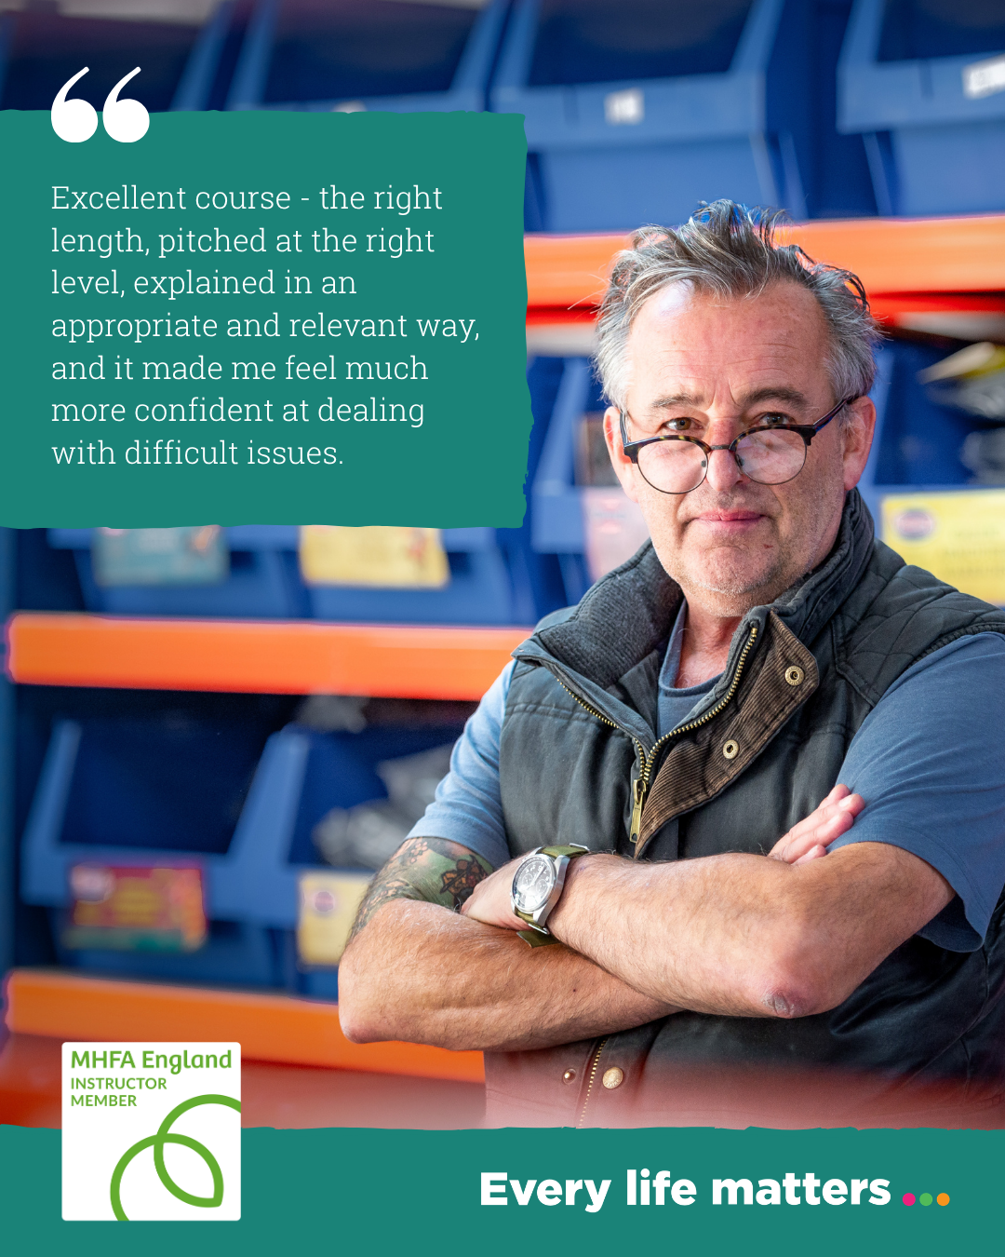

Take me to book my MHFA Training

