

Welcome to the latest edition of Cumbria, Northumberland, Tyne and Wear NHS Foundation Trust (CNTW) newsletter. This edition brings you the latest news and developments from across the Trust - from improvements in patient care to the achievements of our staff, and the ongoing work with our partners and communities.
Thank you for your continued interest and support.

  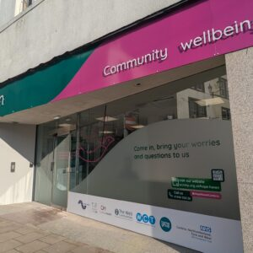
  Hope Haven celebrates new hub opening
  A new chapter in community wellbeing has begun in Whitehaven as Hope Haven opens its new home on King Street. People can drop in for help straight away, with no need for a referral.
  The hub brings together partners, including Cumbria Health, Cumbria, Northumberland, Tyne and Wear NHS Foundation Trust (CNTW), Everyturn Mental Health, Home Group, iCan Wellbeing Group CIO, The WELL Communities CIC and Whitehaven Community Trust. Together, they support people with mental health, housing and money problems, making it easier to get help in the local area.
  

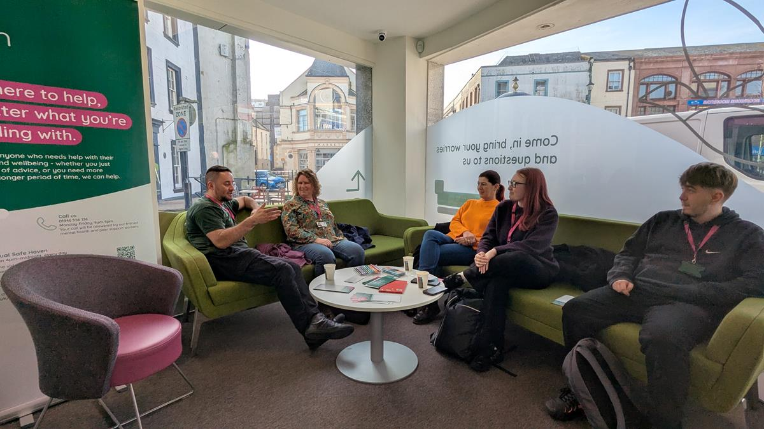

  
  Delivering tomorrow: Shaping CNTW services
  We’re inviting stakeholders to have their say on two important service reviews. The first focuses on the future of adult eating disorder services, looking at how care is provided both in inpatient settings and in the community. The second review is about learning disabilities and autism services, seeking input on how these services can better meet the needs of those who use them.
  You can read more and share your feedback through our online articles: Adult Eating Disorders Services and Learning Disabilities and Autism Services.
  

  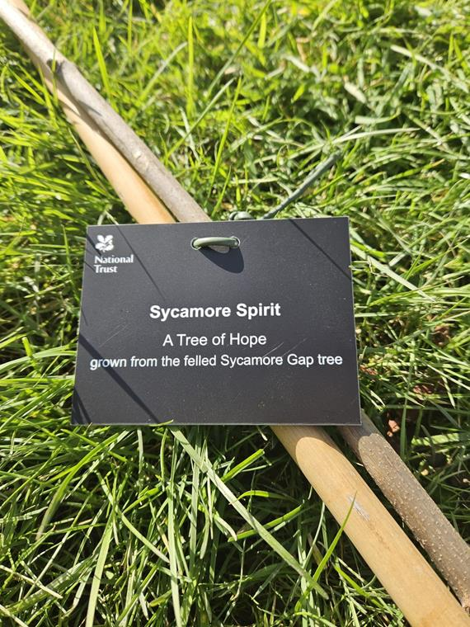
  Trust plants Sycamore Gap Trees of Hope sapling
  A ‘Trees of Hope’ sapling, grown from the iconic Sycamore Gap tree, has been planted in our Sycamore Unit at Northgate Hospital. It creates a calm space for reflection and recovery, and a place where people can pause and feel close to nature.
  As part of a national programme led by the National Trust, the sapling carries on the story of the much-loved tree, offering a gentle symbol of hope and new beginnings for everyone who spends time there.
  

  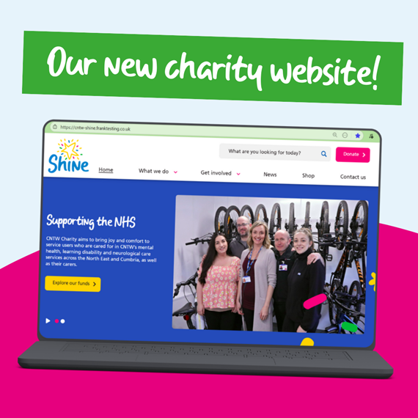
  CNTW Charity - new website
  CNTW Charity has launched a brand-new website, making it easier for people to explore its work and see the difference it makes across services.
  Supporting patients and carers, the charity funds projects that enhance wellbeing, from therapeutic activities to improved facilities - now brought to life through its new online platform.
  

Work for us

We have a number of posts available across a range of specialities across Cumbria, Northumberland, Tyne and Wear.





 |  |  |  |  |  |  |  | 

Cumbria, Northumberland, Tyne and Wear NHS Foundation Trust St. Nicholas Hospital, Jubilee Road, Gosforth, Newcastle Upon Tyne, NE3 3XT.
Unsubscribe.

