All the latest from the Trust | February 27, 2026
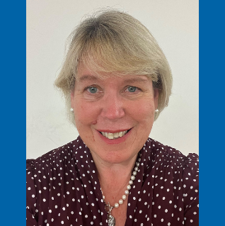
Intro from the Chair
Hello and welcome to our newsletter for foundation trust members and the wider community.

We are working our way through a challenging period but we are working hard to reduce our waiting lists.

You may have noticed that we have had some temporary closures at Keswick Urgent Treatment Centre recently. I’m pleased to say that due to some recent recruitment, we expect to be able to provide a much more stable service by May 2026 and we are restating our commitment to this service.

I was also really touched by the news this week about Olivia Story and her experience of our Specialist Rehabilitation and Mobility Service. The service supports people across north Cumbria with prosthetics, wheelchairs and other mobility aids. It’s one of only nine in England to achieve Murrison Centre status, meaning it is recognised nationally for its specialist support for amputee veterans. We wish Olivia all the best in her future career as a mental health nurse and we are pleased she had such a good experience with us.

It’s great to see that Spring is on the horizon and I for one am looking forward to lighter nights and being able to get into the garden once again. There are also two important religious events taking place this month. Lent and Ramadan are both underway and our chaplains have shared messages to colleagues who are observing these. Ramadan Mubarak to all those observing the holy month.

Until next time,

Teresa Griffiths CBE ARRC
Interim Chair
Operational Update
It’s been another busy month as we have received more support from NHS England to help us reduce our waiting lists. This has been agreed because of the progress we have made in reducing our waiting lists for people who have been waiting for the longest time and a reduction in the number of cancer patients waiting over 62 days. For Urgent & Emergency Care, NCIC was the most improved trust for all types of performance in December 2025 (compared to December 2024) with a 5.9% increase in performance. Whilst we are making good progress, we know there is much more to do, so we are grateful for the additional support to reduce the number of patients waiting over 52 weeks, to increase outpatient activity and get more support from the independent sector.

All of this might mean that patients could be contacted at short notice to attend clinics and that they might be asked to travel out of county for their treatment if they are able. This will help us see as many patients as possible, improve outcomes, and reduce the time they need to wait.

Earlier this month we had an unannounced CQC visit, with a focus on the Emergency Department at the Cumberland Infirmary. It took place during a really busy period and the CQC inspectors observed motivated, kind and compassionate staff who strived to provide good care for our patients and took time to look after each other as well. They did find some areas where improvements are required and we are now working to address these. We would like to say a huge thank you to our ED colleagues and all of those staff who were interviewed and observed over the two days.

Trust restates commitment to Lake District Urgent Treatment Centres
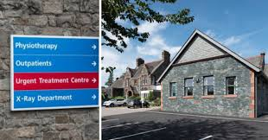
NCIC has restated its commitment to the future of Keswick and Penrith Urgent Treatment Centres.
Since July 2025, there have been a number of days where the Keswick Urgent Treatment Centre has had to close due to staffing issues across both Keswick and Penrith. Where we are not able to safely staff both units, colleagues are brought together at Penrith, to make sure we can still offer an urgent healthcare service in the area.
The staffing gaps, caused by a combination of vacancies and long term absences in a small team are now improving following successful recruitment and we expect to be able to provide a much more stable service by May 2026 when the new recruits join the team..
Dr Gill Findley, Chief Nurse, said: “We are sorry for the inconvenience and confusion caused by the temporary closures, and fully recognise the impact this has had on those who use the service. This decision is never taken lightly but it is important that so that we keep patients safe and continue to provide at least one Urgent Treatment facility in the area.
“Our colleagues have been working extremely hard to maintain the service wherever possible, and we are grateful for their continued commitment during what has been a challenging period. We appreciate the community’s patience and understanding as we work through these challenges.
“We are committed to stabilising the staffing position. We are actively recruiting to vacant posts and colleagues are due to join us in the coming months to strengthen the team.
“We will do everything we can to avoid further closures in the coming months, however it is likely there will be some disruption until new colleagues come into post.”

Car parking payment latest

We are aware that the payment machines at CIC have not been working correctly since December, causing intermittent issues with accepting payments. We are in regular contact with our contractors, and they are working to resolve the issues as quickly as possible.
Members of the public are being advised that if the payment machines at CIC are not working when they visit the hospital, they can pay by another option:
- Cash at reception
- The ‘Your Parking Space’ website (scan one of the QR codes displayed in the car park, or visit https://www.yourparkingspace.co.uk/)
- Download the ‘Your Parking Space’ app (the site code is 12082)
- You can pay up to 48 hours after leaving the site if you pay via the app.

Trust receives Pledge of Excellence for supporting cadets into healthcare careers
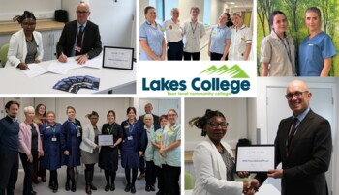
The Trust has received a platinum Pledge of Excellence with Lakes College during National Apprenticeship Week in recognition of the support we provide to encourage young learners into a career in healthcare.
NCIC supports cadets aged 16 to 18 at the Lakes College in Workington through placements as part of their T’ levels in a variety of healthcare professions as they develop their career options.
Last year, we supported 42 placements across two year groups with each student shadowing a clinical support worker for one day a week for six to nine weeks.

Olivia’s patient journey will help support others

For nearly twenty years, Olivia Story has been supported by the prosthetics team at the Cumberland Infirmary and is about to step into a new role as a mental health nurse, carrying her lived experience into her future career.
Olivia has been coming to the prosthetics service at the Cumberland Infirmary in Carlisle since she was a toddler. Now 22, she is close to qualifying as a mental health nurse. She says the care she has received over the years will shape the kind of nurse she wants to become.
Olivia became seriously ill with meningitis when she was just two-years-old and needed a triple amputation. She has used prosthetic legs ever since. As she grew, this meant regular appointments, new legs and lots of adjustments.
The prosthetics she uses are all made on site in the workshop at the Cumberland Infirmary, which is run by NCIC. This means the team can adjust, repair and remake her legs quickly when needed. Phil, who works in the workshop, made Olivia’s very first legs as well as her latest pair.
Her mum remembers coming to the service several times a year, which could last up to two hours each time.
The Specialist Rehabilitation and Mobility Service supports people across north Cumbria with prosthetics, wheelchairs and other mobility aids. The centre is one of only nine in England to achieve Murrison Centre status, meaning it is recognised nationally for its specialist support for amputee veterans.
For Olivia, having the same prosthetist throughout her childhood made a big difference. She has worked with Neil Wallace for around 20 years, since she began needing prosthetics.
Now, after two decades of being a patient, Olivia is preparing to join the NHS herself. She is in the final months of her mental health nursing degree and has enjoyed placements on busy inpatient wards.
Read Olivia’s inspiring story.

Ramadan and Lent

NCIC is supporting colleagues who are observing Ramadan by providing dates and water for those fasting.
Prayer rooms are also available in our chapels and elsewhere for those who need them.
Ramadan is a time for communal prayer, spiritual reflection, meals with extended family and friends to break daily fasts, concluding with the community celebration of Eid-Ul-Fitr, likely to be on or around March 18.
Lead Chaplain Reverend Jane Nattrass said: "In the Christian calendar, Lent is a time where Christians take time to draw closer to God and take time to reflect in the lead up to Easter. Some people will fast, give up meat, fish, eggs and more for the 40 days of Lent. Others choose to give up comforts or luxuries such as chocolate, treat foods, social media or television and may take up extra bible study or engage with Lent courses.”

Charity round-up
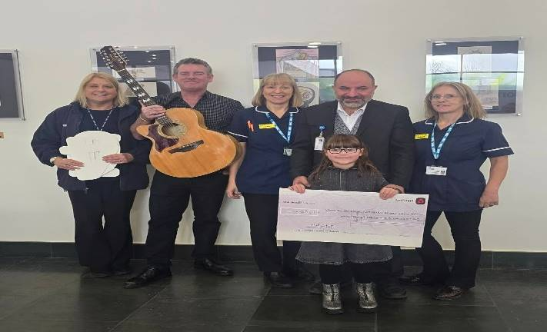
It’s been a busy month for some of our fundraisers and we are grateful to each and every one of them. This month we thank music man Justin Bell, who raised £1,500 for bowel cancer screening after hosting a 12-hour music marathon in Beckermet with his young granddaughter, Aoife.
Justin wanted to raise money and awareness after the bowel screening service detected changing polyps after taking a routine bowel screening test – a test he says he only did because his wife encouraged him to.
After being called for further tests, Justin underwent a colonoscopy and later a specialised keyhole procedure to remove a remaining polyp. He described the experience as far less daunting than he had feared.
Following an anxious wait for results, Justin received the news he was hoping for:
“I got quite emotional, the news was great as I am currently cancer free. If this wasn’t detected, I was told it would have become cancerous. This would have been a totally different outcome.”
The money will go to our charity and will be allocated specifically to the bowel screening service.

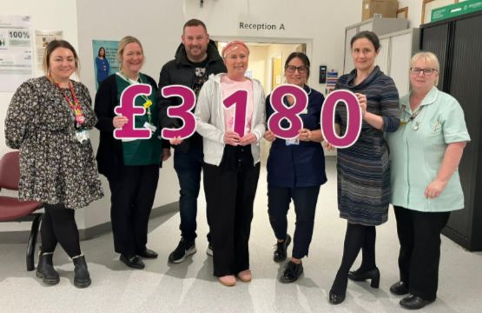
And to solicitor and Carlisle mum, Cheryl Corson, who battled breast cancer and had her head shaved - ahead of chemotherapy - to raise money for the Eden Breast Unit in Carlisle.
Cheryl raised more than £3,180.
Thank you to all of our fundraisers!
If you – or any of your family – would like to raise money for our charity then you can find out more information here.

NCIC Jobs: Would you like to come and work for us?
Check out our current vacancies:

Estates Maintenance Craftsperson Electrical – Carlisle – Band 5

Alcohol Specialist Nurse – Carlisle – Band 6

Governor column by Tracy Ward, Public Governor for Carlisle

Writing an update in the depths of winter could be quite a miserable thing to do. The rain seems endless and I can hardly remember what it is like to walk the dogs without us all being covered in mud! However, when I look beyond the rain and the mud I begin to see the new shoots of spring, brave daffodils starting to show themselves and even a few early lambs in the fields. Life in Cumbria is both beautiful and hard as or farmers and gardeners will verify!

As a governor representing the voice of Carlisle, my role means that I can often hear the negative stories brought about by car parking or long waits in accident and emergency and these are of course valid and bought forward to the leadership team. I promise you that this governing body has some very robust debates on a wide range of issues that you bring to us. But today I want to end on a note of positivity and to report that it really feels like the North Cumbria Integrated Care Trust is experiencing a change of season too.

There are fresh shoots being seen throughout the Trust. A new approach is putting patients experience and the quality of provision front and centre. From a best practice clinical strategy, to tackling waiting lists and earlier diagnosis. The Urgent Treatment Centre comes on line in Spring and will offer an innovative approach to seamless care. Finally I wanted to acknowledge all the hardworking staff and leadership team who overcame the winter challenges admirably and to highlight that Accident and Emergency care demonstrated significant improvements too. It is notable how the community is now sharing positive experiences too. As your governors we are always interested to hear your views so please do keep in touch with us.
Become a member
Anyone living in Cumbria over the age of 14 can become a member, you can choose how much or how little you want to be involved – join today.
Concerns or comments
If you have any concerns or comments please contact your governors on the email below. We are here to raise any concerns on your behalf. More information on the members of the Governors’ Council and their role can be found on our website. If you have any comments or suggestions please contact us via the email below: AskYourGovernor@ncic.nhs.uk

Stay up to date
You can keep up to date with our news on our public website www.ncic.nhs.uk/news or follow us on Facebook, Linked In or via our Instagram feed.
Until next month … thank you
Teresa Griffiths CBE ARRC
Interim Chair

