Changes to parent carer representation from SENDAC to CONTACT
Joint statement from SENDAC and Westmorland & Furness Local Authority regarding parent carer forum arrangements following local government reorganisation.
In 2023, Cumbria County Council underwent local government reorganisation, resulting in the creation of two separate local authorities: Cumberland Council and Westmorland and Furness Council.
Since the reorganisation, SENDAC, the statutory parent carer forum, has continued to operate across both local authority areas to ensure that parent carers retained a collective voice during a period of significant change. Throughout this time, parents and carers from both Cumberland and Westmorland and Furness have actively chosen to engage with SENDAC, and their views have informed discussions and decision making relating to SEND services and support.
Contact, as the organisation responsible for administering parent carer participation funding, has now decided that SENDAC will no longer be recognised as the parent carer forum across both local authority areas. As a result of this decision, SENDAC will move forward as the statutory parent carer forum for the Cumberland area only.
This decision was taken by Contact. SENDAC, the Local Authorities and parent carers across both local authority areas were not involved in shaping the process.
We recognise that many families, including the 687 SENDAC members living in Westmorland and Furness, as well as current and former volunteers, will feel disappointed that parent carer voices were not able to contribute.
What this means:
- SENDAC will continue to operate as the statutory parent carer forum for Cumberland only.
- SENDAC will no longer be able to represent or formally support parent carers living in Westmorland and Furness.
- Parent carers in Westmorland and Furness will no longer be able to access SENDAC services, support or sessions.
- Westmorland and Furness will not currently have a statutory parent carer forum, while work is undertaken by Contact to support the development of future arrangements.
SENDAC would like to express sincere thanks to all parent carers in Westmorland and Furness for the trust placed in us over the past two and a half years. It has been a privilege to represent your voices, advocate alongside you, and build strong relationships with families across the area. We remain committed to the principles of participation, equality and co-production and will offer support where appropriate to help ensure parent carer voice is not lost during this transition.
Westmorland and Furness Council statement
Since the formation of Westmorland and Furness in April 2023, it has been a pleasure to work in close partnership with SENDAC, our statutory parent carer forum.
Together, we have achieved vital work that has strengthened our SEND provision, including improvements to our transport offer, the development of SEMH “All About Me” documentation, and the successful delivery of the PINS project across several schools.
We would like to take this opportunity to sincerely thank SENDAC for their commitment, dedication and passion over the past two and a half years. Their work has ensured that parent carer voice has remained central to SEND improvement activity, helping us to shape services that reflect the needs of families.
As SENDAC moves forward, we wish them every success in their future work. We also look forward to building a constructive relationship with Contact as they support the next phase of parent carer engagement in Westmorland and Furness, ensuring collaboration and co-production continue to drive meaningful change for children, young people and families.
Contact Associate engagement in Westmorland and Furness
The information below has been provided by Contact - for Families with Disabled Children and relates to engagement activity in Westmorland and Furness.
Hello, my name is Laura Burling and I am a Contact Associate supporting parent carer engagement in Westmorland and Furness.
In January, I will be offering warm and friendly engagement sessions for parent carers living in the Westmorland and Furness area. These sessions will provide a welcoming space for parent carers to meet, connect with other families and help shape what is needed locally to support parent carers to be involved in SEND decision making and strategic conversations.
I know this is a time of change, so these sessions are focused on listening, building understanding and agreeing next steps together. There will be a mix of in person sessions at venues across Westmorland and Furness, which will be confirmed, and online opportunities so people can take part in a way that works for them. More information will be shared soon.
If you would like to find out more, get involved or have a conversation, please call 07808 774233 or email laura.burling@contact.org.uk
If you have any queries about this, please contact hello@sendac.org or SENDPartnership.WAF@westmorlandandfurness.gov.uk

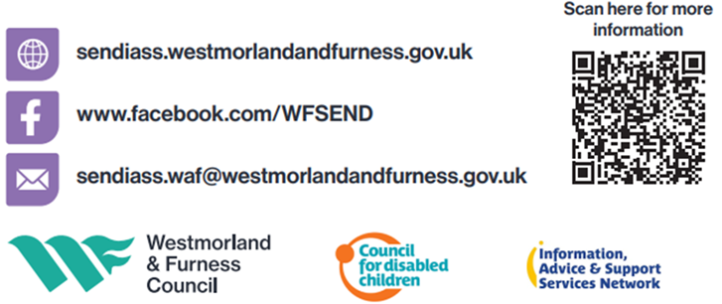
You can visit your SEND Local Offer website here Families Information | Special Educational Needs and/or Disabilities (SEND) Local Offer
If you know any other families with SEND children or young people in Westmorland and Furness who would benefit from receiving our Local Offer Newsletter, please forward this to them or share the information below:
To subscribe to our newsletter, please click the link and enter your email address.
Sign up for SEND updates here

