NCIC NEWS | 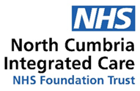
All the latest from the Trust | November 2025

Intro from the Chair
Hello and welcome to our newsletter for foundation trust members and the wider community.

This month we have some excellent news to share – achieving national accreditation for the surgical hub at the West Cumberland Hospital. This recognition is a real achievement and will positively benefit our patients who are treated in the facility. Huge congratulations to everyone involved in achieving this success.
Our winter plans and preparations are in full swing and we are reminding you all to make sure your medicine cabinets are well stocked and keep an eye on our public website for the latest waiting times in A&E. Our social media channels will also have the latest news and winter advice.

A celebration to mark the retirement of former chair Steven Morgan will take place in the boardroom at the West Cumberland Hospital on Wednesday, December 10 at 1pm. You are all welcome to join us to say farewell.

Finally, I would like to take this opportunity to wish you and your family a very Happy and Peaceful Christmas and I hope everyone working over the festive season will get the chance to have some much deserved downtime at some point.

Until next time,

Teresa Griffiths CBE ARRC
Interim Chair
National recognition for surgical hub
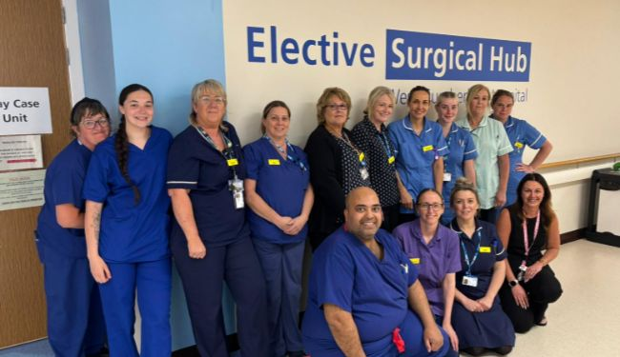
The new surgical hub at the West Cumberland Hospital in Whitehaven has gained national accreditation after demonstrating that it is on track to reduce waiting lists and reduce the time patients wait for surgery. The Elective Surgical Hub is a protected space for planned operations. This keeps operating theatres free to carry out planned procedures such as hip and knee replacements. Keeping it separate reduces cancellations, shortens waiting times and improves overall patient experience. The Hub includes pre-operative assessment, operating theatres, recovery and the surgical ward.
NHS England’s ‘Getting it Right First Time’ (GIRFT) programme carried out an assessment of the Hub in September and has now announced that the accreditation has been awarded. This places North Cumbria Integrated Care (NCIC) among a group of NHS organisations recognised for providing outstanding patient care and operational excellence for planned surgical care.
Trudie Davies, Chief Executive at NCIC, said: “This accreditation opens doors for further recruitment opportunities to attract more staff to come and work with us. It also enhances both patient and staff experience. The West Cumberland Hospital is a real asset to the community and this is another step in our plans to maximise the way we use our excellent facilities to meet the needs of our patients.”

Operational update
The latest data published in November shows that October was busier than September in A&E. It also shows that our waiting lists for treatment and diagnostic tests increased in September despite there being a higher number of diagnostic tests and more people starting treatment than the month before.
We are aware and concerned that our cancer performance has deteriorated. We know this needs to be urgently addressed, which is why the board has reprioritised budgets to allow us to target recovery of our cancer performance. We have seen a slight improvement in performance in September, which is expected to increase further in the coming months.

The second National Oversight Framework ratings are being published in December and we expect that our rating will not yet have been improved, however work is underway to recover our performance. We are seeing a reduction in our overall waiting list however this won’t be reflected in the data until the New Year.

Data on this month’s resident doctors’ strike was published on Sunday (23rd November). At NCIC we saw around one third of our resident doctors striking across the period. We were able to maintain virtually all our planned activity with fewer than 25 outpatient appointments being rescheduled. A huge thank you again to our colleagues who did an outstanding job to keep services safe and running throughout the strike period.

Winter is here!
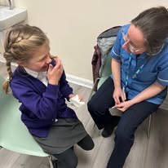
Winter is now here and plans are in place to cope with the additional pressures winter inevitably brings to health services. You can help by making sure you are up to date with your vaccinations. The flu and COVID-19 vaccines are now available for eligible groups, including older adults, people with long-term health conditions, pregnant women and children.
Vaccinations are free and can be booked through your GP, local pharmacy, the NHS App, or by calling 119. Children and young people are being offered the nasal flu vaccine in their school/educational setting. If the child/young person misses their vaccination, requires an alternative to the nasal flu vaccine or requires extra support, there are bookable community clinics available.
Another way to prepare is to stock up on essential items ahead of winter. This includes making sure medicine cabinets are well supplied with cold and flu remedies, pain relief, and any regular prescriptions. Having basic supplies at home can help avoid unnecessary trips out in bad weather or when feeling unwell.
Keeping warm is another key part of staying healthy in winter. Cold weather can have a serious impact on health, particularly for older people and those with existing health conditions. It’s important to heat your home to at least 18C in rooms you use regularly, wear layers of clothing, and use blankets or hot water bottles to stay warm. If you have a lung condition, take a look at the advice from our respiratory experts.

Winter filming – lights, camera, action!
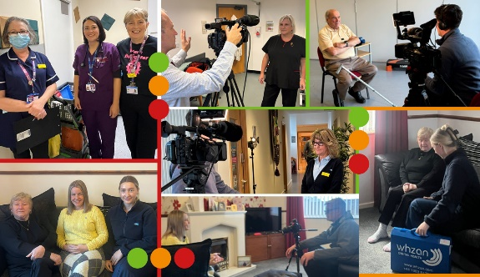
We’ve had a busy few weeks of filming with the local media to raise awareness of key services aimed at helping patients to receive the right care in the right place for them while also reducing pressure on our A&E departments.
The BBC broadcast an NHS special on November 25 looking at how the NHS is preparing for the winter months ahead. Locally with BBC Look North and Radio Cumbria, the focus was on our MATCH hub and virtual wards services. Dr Vicky Gate, who is a GP in the MATCH hub (Multi Agency Telephone Coordination Hub) based in Wigton, spoke about how the service has grown over the past seven months since it opened. Of the 2,638 referrals they received, 60 per cent have received the care they need sooner without going to A&E where they would have previously been referred. Leanne Armstrong, Lead ACP for the frailty virtual wards service, also spoke to the BBC about the benefits of patients not being admitted to hospital when they can receive their care at home.

How Safe Do You Feel?
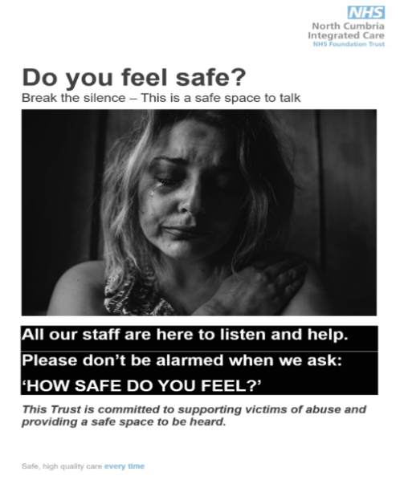
During Safeguarding Adults Week last week, we reminded people about our campaign to give support to people who have experienced or are experiencing abuse or neglect.​
The ‘How Safe Do You Feel?’ campaign explains that staff who work at the Cumberland Infirmary, the West Cumberland Hospital and across all community services will ask as part of their routine enquiries ‘How Safe Do You Feel?’
The Trust would like to encourage anyone who does not feel safe or may be experiencing any form of abuse to access NCIC services as a safe space to speak up.
If you’re experiencing domestic abuse, are worried about a friend/family member, or would like more information about spotting the signs of abuse, immediate help is available.
Safelives.org.uk is a charity dedicated to ending domestic abuse. They have a range of helplines on this page.

New mini lab for West theatres
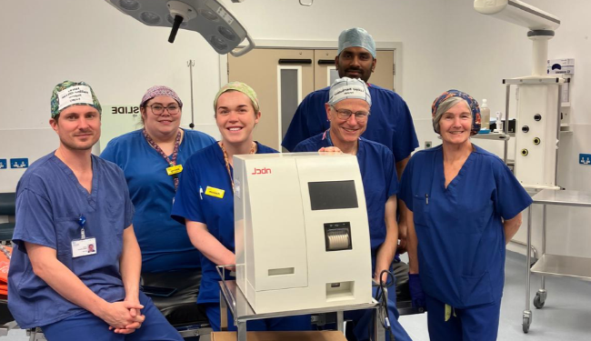
A new mini laboratory for West Cumberland Hospital theatres is making sure patients get home more quickly and improves the overall efficiency of the theatres.
The North Cumbria Hospitals NHS Charity has purchased a £35,000 ‘little box’ point of care testing analyser that can provide vital results in the theatre during a specific operation rather than having to wait until it has been analysed in the main laboratories.
Ludger Barthelmes, Consultant Surgeon, said: “

Parathyroidectomy operations are undertaken when one or more of the parathyroid glands are enlarged. This drives calcium out of the bones and can lead to number of complications including osteoporosis, low impact fractures and kidney stones.
“During the procedure, testing of the parathyroid hormone is required to check that all the necessary tissue has been removed. Prior to the analyser being in place, this involved blood samples being taken and analysed at the busy main laboratories. This took around 40 minutes which doubled operating times and meant that patients could take longer to recover. The new point of care analyser can do this in five minutes.”
North Cumbria Hospitals NHS Charity is fortunate to benefit from many kind donations from the West Cumbrian community. This charitable purchase has been possible thanks to a legacy from the late Leonard Atkinson.

Carlisle Cathedral Christmas tree festival
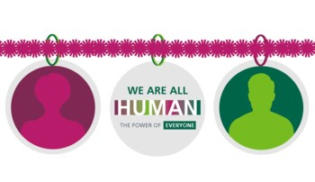
Our chaplaincy team have joined forces with North Cumbria Hospitals NHS Charity this year to take part in this year’s second annual Christmas Tree Festival at Carlisle Cathedral.
The festival will take place at Carlisle Cathedral from Saturday 6th December to Sunday 4th January and as part of Team NCIC you can be part of it.
The theme of our Christmas Tree this year will be our HUMAN campaign. Our 'We are all HUMAN' campaign focusses on the importance of treating each other with kindness and respect.
Photographs of NCIC staff inside baubles will act as a powerful reminder to patients and visitors that no matter their background, those helping them, treating them and caring for them are all HUMAN too.

NCIC Jobs: Would you like to come and work for us?
Check out our current vacancies:
- Community staff nurse (Band 5) at Workington ICC
- GP with special interest in Urgent Care


Governor column by Jacqueline Nicol, Lead Governor
As we are fast approaching winter and the flu season has arrived early, the emergency services and our emergency departments will be under more pressure to look after us all.
We can all help by using the most appropriate service for our illnesses and injuries. Please consider contacting 111 either online or by phone and they will make sure you are directed to the best place.
I can recommend 111 as I have had to contact them twice in the last few weeks. Both times they made sure I was directed to the right service. Once to our Urgent Treatment Centre in Penrith (and soon there will be the UTC in Carlisle.)
So if you need help they are there to direct you to the right place in the right time. You can also see on the NCIC website live waiting times and how many people have arrived in the last hour at our UTC and emergency departments which is really useful.
Become a member
Anyone living in Cumbria over the age of 14 can become a member, you can choose how much or how little you want to be involved – join today.
Concerns or comments
If you have any concerns or comments please contact your governors on the email below. We are here to raise any concerns on your behalf. More information on the members of the Governors’ Council and their role can be found on our website. If you have any comments or suggestions please contact us via the email below: AskYourGovernor@ncic.nhs.uk

Stay up to date
You can keep up to date with our news on our public website www.ncic.nhs.uk/news or follow us on Facebook, Linked In or via our Instagram feed.
Until next month … thank you
Teresa Griffiths CBE ARRC
Interim Chair

