Since we began providing support in March, Hope Haven’s community outreach and one-to-one services have already had a positive impact on so many people. And our hub on King Street is rapidly taking shape, hopefully opening its doors by the end of this year. Read on to find out more…
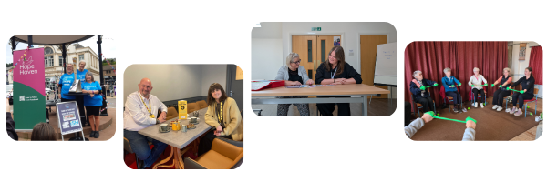

Our growing community support offer
Exercise, advice drop-ins, walks, 'chatty café', and more
Our community wellbeing support offer continues to go from strength to strength. We now offer a regular timetable of activities each week. Sessions include support for carers, housing and money advice, wellbeing walks, fun exercise sessions for all abilities, and a ‘chatty café’:
Tuesday | Wednesday | Thursday | Friday
Senhouse Centre, Whitehaven:  Housing advice and support, 10:30am -2:30pm  Family and friends / carers drop-in, 12:30pm – 2:30pm | Senhouse Centre, Whitehaven:  Wellbeing workshops,  10am - 12 noon  Bellicon rebound trampoline exercise, 2pm – 3pm  The Gather, Ennerdale:  Chair-based exercise, 10:30am – 11am  Ikigai workshops, 12 noon – 1pm | King Street, Whitehaven:  Wellbeing Walks, starting from 40 King Street in Whitehaven, 11am - 12 noon | Senhouse Centre, Whitehaven:  Chair-based  exercise 10:30am – 11:30am  Ikigai workshops, 12:30pm – 1:30pm  Bellicon rebound trampoline exercise, 2pm – 3pm  Cross’s Coffee Shop, Whitehaven:  Chatty café, 10am – 12 noon
Since March 2025, more than 400 people have joined these drop-in activities.
You can also find all our events on our Facebook page.

📞 New phoneline
People can now call us for support between 9am - 5pm Monday to Friday, on 01946 556 136.
Calls will be answered by our trained mental health and peer support workers. They can provide support with mental health, housing, money, and more. And they'll agree a plan with someone for more support if they need it.
People don't need a GP or healthcare professional referral. This phone line is for anyone in Whitehaven and Copeland.
 | ‘Virtual safe haven' offers same-day online support  Our 'Virtual Safe Haven' means people can speak to a trained mental health support worker online via Microsoft Teams, the very same day.  Anyone in Whitehaven and Copeland can visit our webpage to book a Virtual Safe Haven appointment.  They'll get an email confirming their appointment details. When it’s time for the appointment, they can simply click the link and then chat with our friendly team.

There’s no judgement or pressure on these video calls – the team are there to listen, support and help provide information.
If someone needs more support, we can also link them up with one-on-one help from our partners, such as Cumbria Health and Everyturn Mental Health.
The Virtual Safe Haven has supported more than 30 people since it launched in August.
We’ve also supported 94 people one-to-one through Everyturn’s 12-week Together in a Crisis programme. And Cumbria Health have provided 75 physical health appointments.

Our new ‘team of the day’ approach
Hope Haven's new ‘team of the day’ approach brings partners together to offer more streamlined, collaborative mental health and wellbeing support to local people.
Previously, mental health-related referrals often bounced around the health system. People were assessed separately and passed between different services, needing to go back to their GP for different referrals. Sometimes this led to people 'falling through the cracks' or waiting a long time for any help.
Now, Hope Haven partner organisations - CNTW's Crisis and Community teams (including Memory and Later Life, Early Intervention in Psychosis, Learning Disabilities, North Cumbria Talking Therapies, and Pharmacy), Everyturn Mental Health, Home Group, and others - meet twice-daily as a ‘team of the day’.
Together, they discuss new referrals or contacts received by any of the teams. Rather than trying to fit someone into one service's set of criteria, this allows for immediate, joined-up discussions to match people with the most appropriate package of support from the outset.
For example, someone waiting for more specialist support from CNTW can receive more immediate support from Everyturn or Peer Supporters while they wait. NHS teams can alert Home Group if one of their tenants needs additional practical support.
(Rigorous governance and data-sharing processes are in place to support this.)
Short-stay accommodation  In August, we opened two short-stay flats in Whitehaven. These are for people who are seriously struggling with their mental health, and need more intensive support for a short period to stay safe and get back on their feet. A team of specialist staff from Home Group provide 24/7 support.  They enable us to help more people who can’t be safely supported at home or via a day service, without needing to admit them to hospital (which can be very disruptive and difficult for some people).  Adults (18+) can stay in these flats for a short time, up to 72 hours (3 days). Two more self-contained flats are planned. | 
People who may need to use this short-stay accommodation are assessed by CNTW’s Crisis Team and the ‘team of the day’ (see above).
Since August, 5 people have been supported via these short-stay flats, rather than being admitted to hospital.

Work on King Street building is progressing
By the end of this year, we hope to open the doors of our permanent base on King Street – where people will be able to walk in for support every day of the year.
In June-July, repairs to the roof were undertaken. Then, the team got to work stripping out the old interior.
Work is now nearly complete to are completely reconfigure the space inside. It will include a welcoming entrance, private rooms for one-to-one conversations, a physical treatment room, a spacious activity area, and office space where our partner staff can work seamlessly together.
This is a BIG job, across three floors - but the team from Lambert Gill Construction are working really hard to get it ready for you. We’ll keep you updated as soon as we can about when the building will be open.
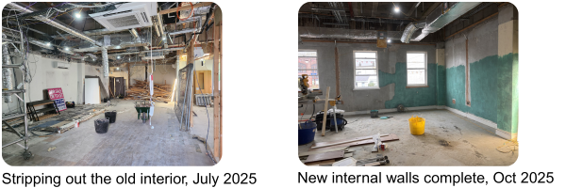

Follow Hope Haven on Facebook @HopeHavenCumbria, visit our webpage, or call us on 01946 556136 between 9am-5pm Monday to Friday.

