The latest news from CNTW ‌ ‌ ‌ ‌ ‌ ‌ ‌ ‌ ‌ ‌ ‌ ‌ ‌ ‌ ‌ ‌ ‌ ‌ ‌ ‌ ‌ ‌ ‌ ‌ ‌ ‌ ‌ ‌ ‌ ‌ ‌ ‌ ‌ ‌ ‌ ‌ ‌ ‌ ‌ ‌ ‌ ‌ ‌ ‌ ‌ ‌ ‌ ‌ ‌ ‌ ‌ ‌ ‌ ‌ ‌ ‌ ‌ ‌ ‌ ‌ ‌ ‌ ‌ ‌ ‌ ‌ ‌ ‌ ‌ ‌ ‌ ‌ ‌ ‌ ‌ ‌ ‌ ‌ ‌ ‌ ‌ ‌ ‌ ‌ ‌ ‌ ‌ ‌ ‌ ‌ ‌ ‌ ‌ ‌ ‌ ‌ ‌ ‌ ‌ ‌ ‌ ‌ ‌ ‌ ‌ ‌ ‌ ‌ ‌ ‌ ‌ ‌ ‌ ‌ ‌ ‌ ‌ ‌ ‌ ‌ ‌ ‌ ‌ ‌ ‌ ‌ ‌ ‌ ‌ ‌ ‌ ‌ ‌ ‌ ‌ ‌ ‌ ‌ ‌ ‌ ‌ ‌ ‌ ‌ ‌ ‌ ‌ ‌ ‌ ‌ ‌ ‌ ‌ ‌ ‌ ‌ ‌ ‌ ‌ ‌ ‌ ‌ ‌ ‌ ‌ ‌ ‌ ‌ ‌ ‌ ‌ ‌ ‌ ‌ ‌ ‌ ‌ ‌ ‌ ‌ ‌ ‌ ‌ ‌ ‌ ‌ ‌ ‌ ‌ ‌ ‌ ‌ ‌ ‌ ‌ ‌ ‌ ‌ ‌ ‌ ‌ ‌ ‌ ‌ ‌ ‌ ‌ ‌ ‌ ‌ ‌ ‌ ‌ ‌ ‌ ‌ ‌ ‌ ‌ ‌ ‌ ‌ ‌ ‌ ‌ ‌ ‌ ‌ ‌ ‌ ‌ ‌ ‌ ‌ ‌ ‌ ‌ ‌ ‌ ‌ ‌ ‌ ‌ ‌ ‌ ‌ ‌ ‌ ‌ ‌


Welcome to the latest edition of Cumbria, Northumberland, Tyne and Wear NHS Foundation Trust (CNTW) newsletter. This edition brings you the latest news and developments from across the Trust — from improvements in patient care to the achievements of our staff, and the ongoing work with our partners and communities.
Thank you for your continued interest and support.

  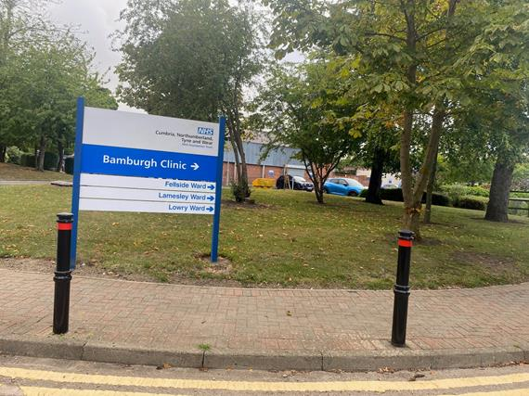
  Bamburgh Clinic Reopens After Redevelopment
  Our newly refurbished Bamburgh Clinic at St Nicholas Hospital, Gosforth, has officially opened. Part of the government’s New Hospital Programme, the upgrade marks a major step in improving patient care and facilities.
  

  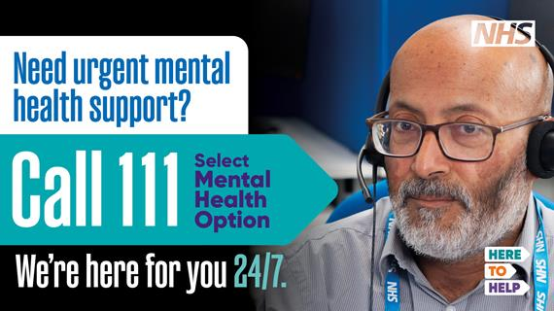
  New Way to Access Crisis Mental Health Support in the North East and Cumbria
  Last year, the NHS 111 ‘mental health’ option was launched across the country. That means wherever you are, you can get help in a mental health crisis by calling NHS 111.
  

  
  Reminder: Annual General Meeting and Celebration Event
  Join us on Tuesday 23rd September 2025 at the Jubilee Theatre, St Nicholas Hospital, Newcastle upon Tyne (or via Microsoft Teams).
  9:30am – 12:00pm: Refreshments and marketplace stalls
  12:30pm – 2:30pm: Celebration Event 2025
  A chance to chat with our Trust and partner representatives, Council of Governors, and Board of Directors about our work.
  

  
  SHINE Celebrates Record Support at the Great North Run
  On 7 September, 15 amazing supporters took on the Great North Run to raise funds for SHINE, our charity that enhances the experience and wellbeing of people receiving mental health, learning disability and neurological care across the Trust.
  

Work for us

We have a number of posts available across a range of specialities across Cumbria, Northumberland, Tyne and Wear.





 |  |  |  |  |  |  |  | 

Cumbria, Northumberland, Tyne and Wear NHS Foundation Trust St. Nicholas Hospital, Jubilee Road, Gosforth, Newcastle Upon Tyne, NE3 3XT.
Unsubscribe.

