

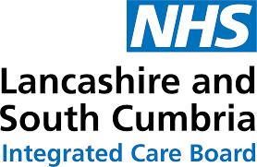

SME Breakfast: Helping businesses to support their employees to stay well in work

A series of business breakfasts have been set up in South Cumbria to help employers support their employees to stay well in work.
The two breakfast sessions will take place in October, bringing together the owners of small to medium enterprises to share current initiatives that businesses can use to support employees physical, psychological and social needs.
The session will cover:
- Context and data outlining the impact of sickness absence locally

- Details and resources on becoming an inclusive workplace, including making reasonable adjustments, supporting neurodiverse employees and becoming disability confident employers

- Information and access to WorkWell, a fully funded service providing tailored help and assessment for individuals who are struggling at work due to their health or are taking a leave of sickness absence. For further information on WorkWell visit: WorkWell - The Bay Anchor Network
Details of the breakfast events are below.
Kendal Rugby Club, Wednesday 1 October, 8:00am- 10:30am
Barrow Town Hall, Monday 6 October 8:00am- 10:30am
To book your place -
Kendal – https://forms.office.com/e/yMibqWT2Mx
Barrow – https://forms.office.com/e/svHptsTBVE
Or there are QR codes available to scan below!

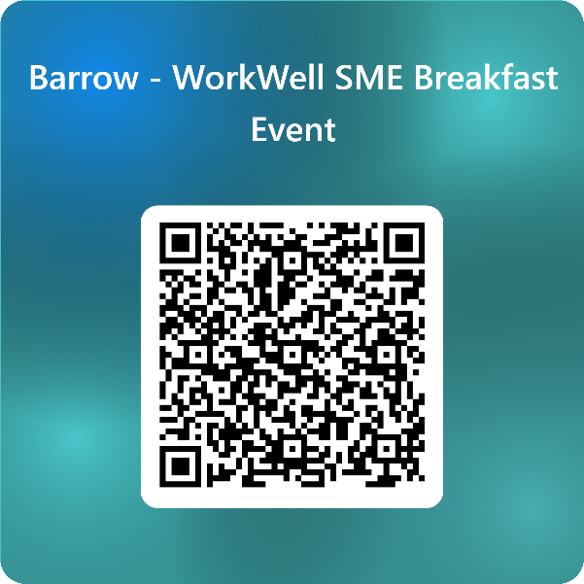


The business breakfasts are completely free to attend and refreshments will be provided upon arrival.
If you would like to discuss the upcoming sessions in more detail, please contact: Claire.muir3@nhs.net

ENDS//

