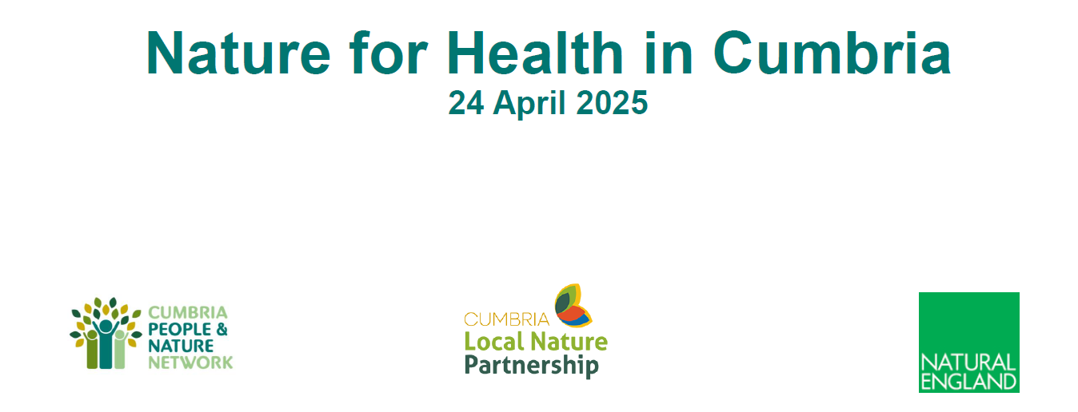
The "Nature for Health in Cumbria" event held on 24 April 2025 in Carlisle, focused on integrating nature and health and wellbeing across Cumbria. ​The event brought together c. 70 stakeholders from public health, environmental organisations, local councils, and community groups. Key themes included the integration of nature and health, nature and wellbeing (with a focus on mental health), cross-sector collaboration, and healthy place-making including the Nature Cities & Towns initiative.

Agenda:
The event included scene setting talks that led to a series of workshop style activities to gather views and expertise from attendees.
- Welcome: Jodie Mills, Chair of Cumbria People and Nature Network. ​
- Partnerships for Nature and People: Jody Ferguson, Manager of Cumbria Local Nature Partnership, emphasized strategic collaboration for nature recovery. ​
- Nature for Health Approach: Colin Cox, Director of Public Health and Communities at Cumberland Council, discussed the connection between health, nature, and community recovery. ​
- Investing in a Natural Health Service: Mary Smith, CEO of Growing Well, highlighted the importance of nature-based mental health interventions. ​
- Healthy Place-Making: George Coombs, Senior Officer at Natural England, explored creating spaces that benefit health and biodiversity. ​

Presentation Slides:
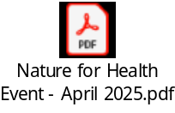

Activities:
- Activity 1: Envisioning a Nature for Health approach in Cumbria. ​
- Activity 2: Addressing challenges and fostering cross-sector collaboration for a sustainable Natural Health Service. ​
- Activity 3: Achieving healthy places for people and nature through system-wide and localized changes. ​

Key Themes:
- Nature and Health Integration:
  - Nature recovery is linked to community recovery. ​
  - The "Natural Health Service" model promotes mental and physical health through green spaces and activities. ​
  - Scotland’s Green Health Partnerships serve as a model for improving access to nature-based health solutions. ​
- Mental Health Crisis:
  - Mental health issues are a growing concern nationally and locally, with significant economic and social impacts. ​
  - Nature-based interventions, such as horticultural therapy, offer cost-effective alternatives to traditional care but they need to be well designed and properly resourced. ​
- Challenges and Opportunities:
  - Cross-sector collaboration is essential to foster sustainable natural health services. ​
  - Barriers include fragmented spaces, lack of clear asks, and skills gaps. ​
  - Opportunities lie in creating connected networks, improving governance, and integrating nature into statutory services. ​
- Healthy Place-Making:
  - Emphasis on creating accessible, high-quality green spaces to improve health outcomes and reduce inequalities. ​
  - Urban tree canopies, natural spaces, and inclusive design can enhance mental health and community resilience. ​
- Nature Cities & Towns Initiative:
  - A partnership to inspire local authorities to prioritize nature recovery in urban areas. ​
  - Focus on health, climate resilience, and community engagement. ​

Summarised feedback from activities:

Activity 1: What would a Nature for Health Approach in Cumbria look like to you?

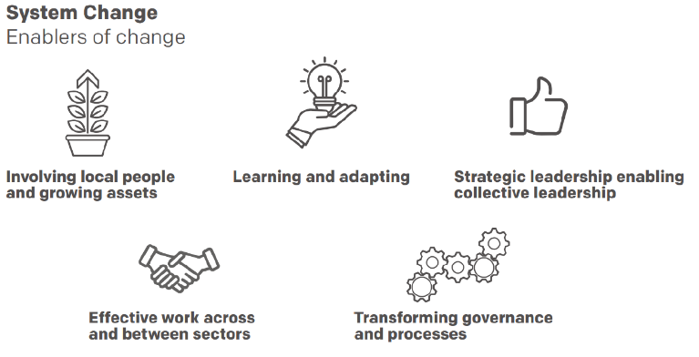
Attendees reviewed Enablers of Change and scored where they think we are in Cumbria at the moment on a scale of 0-4 (0 being very poor and 4 being very good).

Summarised feedback:

Learning & Adapting: Good networks exist, but more visibility and long-term funding are needed.

Strategic Leadership: Inconsistent across sectors; need for integrated strategies / frameworks.

Cross-Sector Work: Promising start, but still fragmented.

Governance: Overly complex; need for simplified, inclusive processes.

Local Involvement: Strong grassroots interest, but accessibility and coordination are lacking.

Activity 2:

Q: How do we work cross-sector to foster a sustainable Natural Health Service in Cumbria?
A holistic, accessible, and well-governed service integrating nature into health.
Q: What are our biggest challenges in creating a Natural Health Service in Cumbria?
Challenges: Cultural mindset, funding, transport, lack of coordination.
Q: Can we turn said challenges into opportunities? If so, how?
Opportunities: Long-term savings, school engagement, social prescribing, and community empowerment.

Activity 3: How do we work cross-sector to achieve healthy places for people & nature across the county?
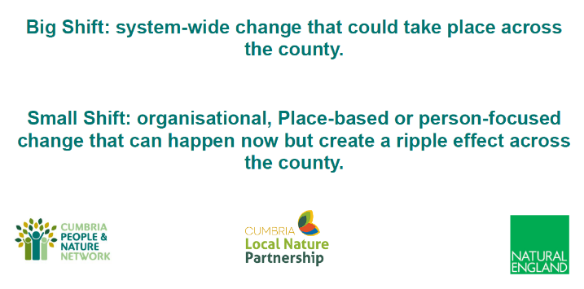
Big Shifts: Policy reform, green infrastructure, integrated leadership, and campaigns.
Small Shifts: Local park improvements, school nature programs, and community-led design.

Next Steps
1. Develop a strategic framework for integrating nature into health services across Cumbria.
2. Secure long-term funding and resources for nature-based health interventions.
3. Foster cross-sector collaboration and simplify governance processes.
4. Promote the benefits of nature-based interventions to address the mental health crisis.
5. Engage local communities in healthy place-making.

Conclusion:
The event emphasised the importance of integrating nature into health strategies, addressing mental health challenges, and creating sustainable, inclusive spaces for people and wildlife. ​ It called for collective action across sectors to achieve these goals. ​

Full feedback

Activity 1: What would a Nature for Health Approach in Cumbria look like to you?

Attendees reviewed Enablers of Change and scored where we are in Cumbria at the moment on a scale of 0-4 (0 being very poor and 4 being very good).

Learning and Adapting
4 – Very good  No comments | 3  Do we really know how interconnected we are  Very informative good to see  I am surprised how much is already happening  How to share learning for quicker adaptation  Good networks in Cumbria generally. Partnerships between sectors are well developed  Hot bed of activity, just need to continue the coordination and promotion  So much rubbish
2  More funding for long term projects to enable learning and adapting  Celebrate successful change hugely  Start with the youngest i.e. early years (0-5 years) make it their norm. Children would also draw adults in as they ‘teach’ parents/families  Targeted volunteer opportunities  Events like today and the partnership are brilliant to share learning  Seeing more and more skills sharing and collaborative working – helps us learn from each other  People & Nature Partnership driving this forward but needs to be higher profile so more people are aware of it  Progressing well, seeing more projects and engagement  Learning often lost, evaluations fall on deaf ears. Pilot projects succeed yet still die.  Need to adapt more to people’s needs. Transport is a huge barrier for people.  Lots of learning available, however, can be difficult to find if you don’t know where to start.  What have we learnt from current programmes – what do people want, what are the gaps?  Sharing not always evident – of ideas and things that work  Things are improving now but it has taken time and can be difficult to encourage others (who maybe are not as passionate about nature) to adapt.  Not sure if the value of nature is appreciated or if green space just hasn’t been built on yet for example  Often more by accident than design. | 1  More speed/priority at learning and activating people to make changes  Are there methods for sharing learning?  Need to ensure people’s basic welfare needs are being me to ensure they can actually do/engage with the activities and the ideas in order to action positive change  This MUST include all age groups – how are children and young people considered in this agenda? Engagement with schools is vital with an understanding of their challenges to collaborate and develop solutions/actions.
0 – very poor
No comments

Strategic Leadership Enabling Collective Leadership
4 – Very good  No comments | 3  No comments
2  We have people but not funding  People and Nature Partnership driving this forward  Impact of LGR – Lack of clarity around roles in LA  LGR means new partnerships informing but early days  Involvement of health researchers – delegate where appropriate?  In some areas but climate and nature often left out | 1  Need a framework/strategy for delivery – is there one?  Needs integrated strategy across H&SC & businesses  Attitudes of those ‘at the top’ seem slower to change. Priorities aren’t nature orientated  Some are not interested in climate and nature  Strategy planning across organisations needs to increase to work more collectively  Unsure what, if anything, is happening  Theory is great but the theory needs to be actioned  Leadership not consistent or joined up across organisations  Funding and lack of will need to be better structured and longer term to support joined up working  Strategy/policy needs to be accessible and include evidence of collaboration and contributions from all ages, communities and sectors  Unsure, it’s not happening in the NHS  How to access more funding and assets – involve local business, housing developments eg green space, community allotments  Does the NHS believe in green social prescribing? The links seem to be broken  Good in environmental sector but not in health  Often to much in-fighting over limited funding to allow collective leadership to be taken into decision-making process.  First time I have been engaged – quite impressed
0 – very poor
No comments

Effective Work Across and Between Sectors
4 – Very good  No comments | 3  Not so sure but if today is representative then a great start  Having a nature network and events such as this is helpful & we have the advantage over areas without such leadership  There are lots of networks across sectors and increasing  Cumbria P&N network really helps this  I think we do this well in Cumbria  Things like this are a catalyst for change, hopefully the CPNN is helping  What might be some robust measures of success  In its infancy but we have a ‘Cumberland Early Years Happy Healthy Pledge’ – promotes partnership working  The partnership seems like a good start towards clearer communication between sectors  It’s starting, needs normalizing eg no competition or whose badge is on it – same goals  Think the mix here says a lot  Unaware of what is available and how to access it
2  Keep simple! Like Nature!  People and Nature partnership driving this forward  Always ways to improve – same lack – people, internet, travel  Funding needs to be available to allow and encourage this  Cumbria is huge – local versions of People & Nature Networks may be beneficial  Currently project driven – not business as usual  Some good pockets but significant challenges especially in health with strategic vacuum and paralysis  Need to be able to access resources and funding in a joined up way – how?  Need to improve collaboration between services, what services exist, how can we support each other to be successful and benefit individuals. Work to address barriers  Some work has started but more links need to be made  Great collaboration work between organisations, however, a lot of projects are isolated | 1  Good intentions but lack of obligation to do this. Connecting to the health sector is challenging  Looking at other sector policies through a nature and health lens more, i.e. active travel, increasing biodiversity  People Nature Network, CAPS, Action in Cumbria seem to be leading the way
0 – very poor
No comments

Transforming Governance and Processes
4 – Very good  No comments | 3  It can be quite hard to get in front of the right people and an understanding of wanting to collaborate and not be in competition  There’s a lot of separate strategy, local and central government led and third sector led activity. Lots of good resources and sharing, I feel we lack the means to share what is going on in Cumbria, what is our shared aims and what is the evidence of its impact.
2  Still improvements to be made – engaging community, businesses etc  Keep it simple  Less bureaucracy and more devolved power so the governance and processes of each district area in Cumbria can be met  Governance and processes are often confusing, processes are overly complicated. Funding windows are short  People and Nature Partnership driving this forward  Significant barriers to mobilizing assets e.g. education/climate/health planning  I feel we need some method to simply describe the multitude of short aims and impacts. What does improved “health” look like and how is it getting better/worse as a consequence of our various actions. Without a shared sense of mission & impact it’s an overwhelming mass of disjointed work  Lots of great intentions but intervention services need to be carefully defined and robustly governed not just #mentalhealth  Dog walking for RSPCA, plots in residential areas for the aging population, grow fruit and veg, multiple beaches volunteer and commercial opportunities  Lots of red tape, small funding pots with specific limitations on how it is used | 1  Slow progress in public sector services  Regular consistent funding from government – they need to believe in Natural Health Service too  Too much change/upheaval recently  Great on paper but difficult to make an impact for real change and for public sector/private sector to commit funding to 4rd sector  Need to be open to change. Share with other organisations  Consistency issues and maybe more talk than action  Authority restructure has taken time and resources away from delivery  More information/structure needs to be available to ensure groups/projects/organisations follow a process  Making small steps where individuals are putting in effort, not always strategically led  Feels like a county wide framework is needed  Involve everyone all ages of strategic group with all sectors  Bicycle Mayor model? 3 year volunteership on single issues  Doing this around the edges of peoples roles, not resourced sufficiently as having to do this
0 – very poor
Not evident in the NHS or medical practices
Limited by Government mechanisms
What does a more efficient Government process look like? Any money?

Involving Local People and Growing Assets
4 – Very good  No comments | 3  More work around transport issues, hard to reach individuals. Look at how businesses can support. More focus groups with HI areas  Reach out to various sectors, education, MOD, NHS, Local Government  Local communities need practical support such as bus routes/transport links to green spaces which have been removed by funding cuts  Lots of interest but no idea where to start & how to find opportunities  Aware of schemes but see SO much more can be done  Street/neighbourhood created – not so much organisations  Lots of local projects but some are hidden away  Lots of community led initiatives from local volunteers in Kirkby Stephen/Brough with active engagement from residents  Lots of grass roots local initiatives – community gardens  Accessibility for a lot of people isn’t great which hurts participation  A lot is inaccessible to people  Voluntary opportunities available via CVS Cumbria  Some engagement with local communities to do conservation, gardening and other nature based activities but could be more  Need to work on reaching the hard to reach groups  Any initiatives prioritizing local involvement are disparate with different specific aims – from generic volunteering to specific health outcomes. We need stronger coordination, alignment of social aims and a commitment to collectively evidence impact  Co-production engagement  Need more tiny opportunities for health especially people with mental health issues. Cumberland Council Green Space team run great volunteer programme, also Eden Rivers Trust, friends of various parks also good volunteering opportunities  Logistical challenges, transport to and from site. Methods of communication, social media is limited vs Word of Mouth
2  Work has started but more to be done to raise awareness  Share more knowledge and resources – better comms  Amazing green spaces – access to local community is limited  Active charities and NGOs & local government/National Park projects. Not well coordinated or plugged in to health  Place action groups & Community panels – is nature a priority to them?  Evident in some organisaions, in others “things” just happen, not necessarily focused on local need  Need a local partnership – district level – linking HAW’s, SPS, Health/care navigators and environment groups – or is there already these?  Reaching community group but not having the same impact on individuals so they use their own initiative to ‘action’ or seek out opportunities AKA a lot of preaching to the converted sometimes  Needs more embedding – give local people time to take part in these projects. Time out from work, childcare, increase accessibility  NHS across the board needs to value this  Get people young – schools matter hugely  Off to a good start but could do more, especially the councils  I am proof it is connecting locally but found the partnership by accident  Really good examples but tend to be those with most social/financial capital. Not so good with urban and coastal | 1  How is this being done – any best practice?  Is there a true cross sector of people involved? E.g. are working people excluded from opportunities in working hours?  We need local business people to be enthused - philanthropy
0 – very poor
No comments

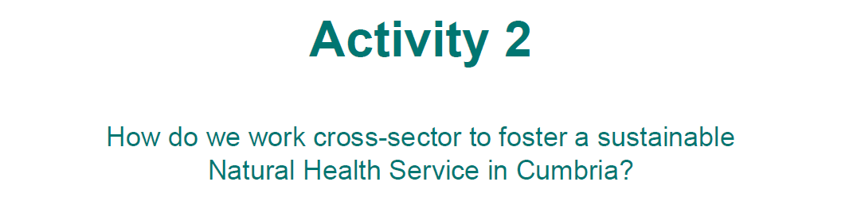
Part 1 - What would a “Natural Health Service” in Cumbria look like to you?
All partners committed to the creation of a physical “Natural Health Service” that is fully resourced and integrated into local policies and procedures. Focused on prevention and early intervention.
Qualified professionals to correct level
Evidence based/led
Accessible transport/equity of access
Clear level of service (patient vulnerabilities)
High quality, nutrient rich food in hospitals
National strategy & training – common approach and standards e.g. public procurement of food, garden in every school, green spaces in every community
Prevention not just cure – promoting good healthy behaviours
Well financed
Service user evaluation
Inclusive
PHE Guidelines
Skill improvement
Individual approach/personalized – what are their needs
Green spaces – group sessions, bio-diverse
Governance is key, being well intentioned is not enough
Outcome focused
Early intervention – children/young people
Connected with nature into everyday life
On our doorstep
Menu of interventions/’treatments’
Alternative medicines/therapies
Making cities healthier – pollution, water fountains, heat islands
Being clear about service aims and purpose – stay in your lane
Facilitating people to enjoy nature
Staff need training and knowledge to be able to offer appropriate support which safeguards vulnerable people being referred
Targeting ‘hard to reach’ is crucial
Need (from top) for nurseries, schools etc to be involved in nature – set the trend early.
Hospitals with nature reserves, cycling routes, park runs etc
Integrated
Nature fully recognized as a beneficiary
Well administered and proactive
Buddy system to invite, welcome and support new participants
Qualifications/training benefits for participants
Central, up to date hub – directory of providers/support available
Part 2 - What are the challenges in creating it.
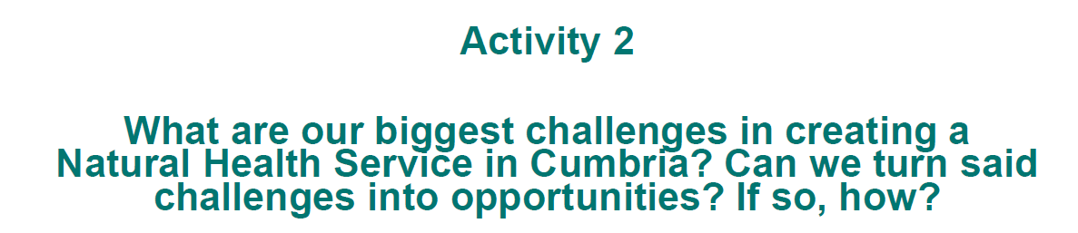
Mindset changes/culture. Mindset needs to change from pharmaceutical to more holistic and natural
Lack of role models – social influencers
Transport
Communication – honest and accurate – reach everyone
Funding – competition – short term
School curriculum doesn’t have space
Ensuring interventions have green/nature pathways
Accessibility for all – take nature to people
Taking personal responsibility
Co-production/engagement
Connections – establishing
Support/training/safeguarding not in place for providers
Many people not ready to participate in a group activity, want 1 to 1 support
Social prescribers overwhelmed. Not enough capacity to engage with communities and providers
Most providers are not specialist in mental health support
People put off joining established volunteer groups
Lack of connections/collaborations between sectors – no joined up thinking
Difference regarding priorities of sectors
Health and nature – no strategy
Some sectors e.g. NHS, broken – weak/poor leadership and management
Needs to be tailored to the needs of Cumbria
Challenges with coordination across organisations, branding, promotion
How to measure ongoing impact
Gaining people’s confidence in different pathways
Lack freedom to adapt
Buy in from all different parties needed
Geographical and health boundaries
Connectivity of service need and trusted projects
Targets within NHS need to reflect social prescribing
Central platform needed
Splits in NHS and Councils
Supply/demand of resources
How to engage whole families
Lack of confidence from inexperience
Part 3 – Opportunities
Long term cost savings and health improvements
Social prescribing networks/central referral hubs
Cumbria is the perfect place for a Natural Health Service
People are more aware of wellness and investing in themselves
Engage with schools and the curriculum – learning to manage their wellbeing
Devolution?
People are more likely to open up outside
Take decision makers/funders to see in real life – plus social prescribers, link workers, health professionals
Have services everywhere – where people can walk and cycle to
Develop a framework so organisations can see where they sit – in “which lane” – at what level of need with common framework for evaluation
Common branding for voluntary organisation to show connection
Focus of values – honesty, empathy, compassion, trust
Take control – facilitate sector collaboration to agree shared goals, actions and outcomes that are measurable and therefore can be reviewed
Remove complex bureaucracy – keep it simple – central directory, agreed referral pathways
Initial conference days to analyse barriers & explore/decide solution

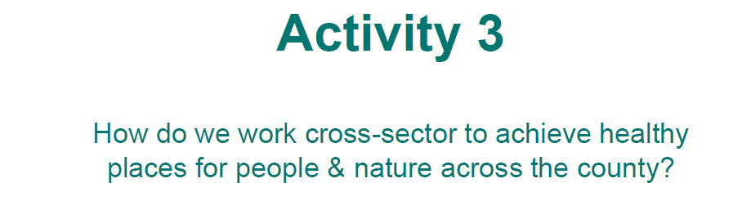
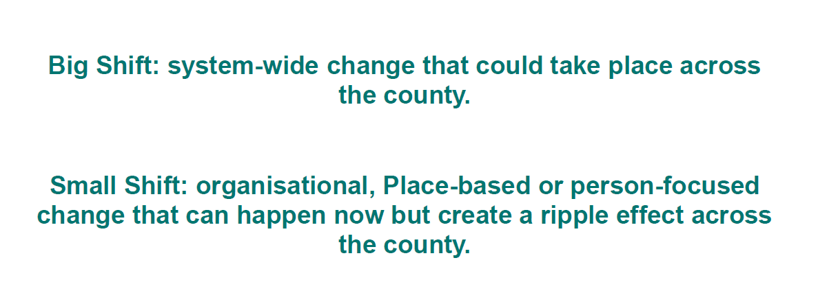
Big Shifts
Create the system – write the policies, break down the silos, maximise the money
Civic Centre to be replanted as a green wall
Sponsor Carlisle and Barrow football clubs/rename Brunton Park to reflect the green agenda
Make urban grass lands more bio-diverse
Green tax rather than tourism tax for the lake district
Improve public transport -all bus fares £1, family tickets
All statutory contracts have a ‘green’ clause
Off road footpaths to all primary schools (cycle/walk to school)
Car free days in areas
All schools have 1 hour a week outside – mandatory
Solar panels on all new buildings
All councils restrict all takeaways
Improving parks so they are accessible for all and become outdoor community hubs – stage events etc
Have locals involved in designing parks (young people, older people, disabilities etc)
Green our urban spaces e.g. Civic Centre replanted
A system wide change to focus on prevention rather than reaction – education, valued green spaces, connected transport/active travel, standardised system of social prescribing within the NHS.
All aspects of Human Health, Animal Health and the Environment given equal weight in all decision making – we are nature
Create a model (e.g. Cumbria Compact) to bring together sectors – could begin with local groups that feed into the Cumbria wide group – keep it simple, outcome/impact focused – learn from best practice elsewhere, fully funded – Government and other partners, intergenerational work – young people working alongside sector groups/decision makers
Community voices captured – How? Targeted
Greener grounds in schools – mini nature reserves – link to a local environment group/charity for support/volunteers to help develop and maintain
Think long term – children are the politicians of the future
Integrated leadership through co-employment and therefore at all levels of organisation e.g. Walsall Together (Local Authority, Health, VCSFE, Environment and other statutory bodies/agencies) possibly facilitated by devolution.
Devolve budgets and control to Cumbria
National Services for Natural Health Service
Any land not in ‘favourable condition’ transferred with a revenue and capital sum to the Natural Health Service
National marketing/campaign for ‘messy’ nature recovery. It’s not abandonment it is nature!
Attendees
First name | Surname | Organisation
Lianna | Barrie | Cumberland Council
Wednesday | Batchelor | Tullie Houe Museum & Art Gallery
Florence | Bell | Cumberland Council
Lizzy | Benn | Cumbria Wildlife Trust
Karen | Bentley-Brown | Future Fixers CIC
Raegan | Blacker | Workington Nature Partnership/Cumberland Council
Natalie | Bowers | Creative and Freelance Producer of community arts events, Eden Arts
James | Cobbold | Cumbria Community Forest
John | Coburn | Cumbria Community Forest
George | Coombes | Natural England
Gill | Conroy | West Cumbria Rivers Trust
Colin | Cox | Cumberland Council
Susan | Denham-Smith | The Wild Wool Barn
Tania | Desborough | North East and North Cumbria ICB
Laura | Farrell-Pronesti | Groundwork North East and Cumbria
Jody | Ferguson | Cumbria Local Nature Partnership
Leanne | Fisher | Watchtree Nature Reserve
Louise | Foster | Westmorland and Furness Council
Philippa | Golightly | Groundwork North East and Cumbria
Jen | Green | Natural England
Nick | Greenall | Creative Communities CIC and Windermere Science Festival
Rebecca | Greenfield | Yorkshire Dales National Part Authority
Philip | Hargreaves | NHSLSC ICB
Claire | Harris | Natural England
Alison | Hooper | Cumbria Development Education Centre
Kate | Jackson | Natural England
Raeesa | Jassat | University of Central Lancaster
Shayla | Johnston | Groundwork North East and Cumbria
Karen | Jones | Natural England
Marian | Jones | Cumbria Wildlife Trust
Meinir | Jones | Westmorland and Furness Council
Stacey | Kelton | Carlisle Healthcare
Helen | Kirkby | Natural England
Anna | Larden | Active Cumbria
Hanna | Latty | Lake District National Park
Emma | Mackie | Cumberland Council
Ellyse | Mather | Environment Agency
Jonathan | May | Cumberland Council
Lisa | Mcewan | Cumberland Council
Jodie | Mills | West Cumbria Rivers Trust
Beth | Moore | Westmorland and Furness Council
Jessica | Mordain | Cumbria Wildlife Trust
Steven | O'Keeffe | Cumberland Council
Sarah | Penn | Cumbria CVS
Ursula | Pool | University of Central Lancaster
Dan | Richards | Cumbria Wildlife Trust
Christine | Riddell | Cumberland Council
Derek | Robinson
Helen | Roe | Watchtree Nature Reserve
Karen | Rutter | Cumberland Council
Rebecca | Seaton | Barnardos LINK
Laura | Singleton | Solway Coast National Landscape
Rebecca | Slack | Cumbria Biodiversity Data Centre
Danny | Smith | Cumbria CVS
Mary | Smith | Growing Well
Tom | Speight | Cumbria Arts and Culture Network
Monique | Speksnyder | Wildlife for Wigton
Kristel | Taylor | Natural England
Helen | Tickner | Cumberland Council
Alice | Wetenhall | Cumberland Council
Charlie | Whinney | Artist, Charlie Whinney Studio
Ben | White | Cumberland Council
John | Whitton | Diocese of Blackburn
Kristine | Zepa | Cumberland Council HDRC

