Welcome to the latest edition of Cumbria, Northumberland, Tyne and Wear NHS Foundation Trust (CNTW) newsletter. This edition brings you the latest news and developments from across the Trust — from improvements in patient care to the achievements of our staff, and the ongoing work with our partners and communities. Thank you for your continued interest and support.

Cumbria, Northumberland, Tyne and Wear NHS Foundation Trust (CNTW) welcomes the aims of the NHS 10-Year Plan, which sets out a clear vision for more community-based, preventative, and digitally enabled care. The focus on improving access to mental health services, tackling health inequalities, and investing in the NHS workforce closely reflects our own ambitions.
Our Strategy, With You in Mind, shares this commitment. Through our five strategic ambitions, we’re working to deliver high-quality, person-led care, support staff wellbeing, embrace innovation, and strengthen partnerships with our communities. We know we can’t do this alone—collaboration with service users, carers, staff, and partners across the region will be vital to making lasting change.
In the weeks and months ahead, we look forward to sharing updates and stories that show how we’re bringing these ambitions to life—together.
James Duncan, Chief Executive

  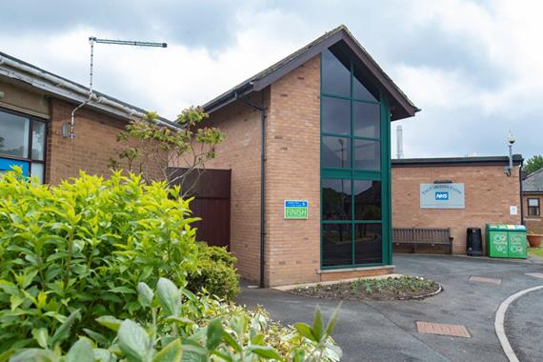
  Move of acute adult assessment and treatment inpatient services from Yewdale Ward to Carleton Clinic
  CNTW Trust Board has made the decision to relocate acute adult assessment and treatment service from Yewdale Ward in Whitehaven to additional inpatient beds at the Carleton Clinic in Carlisle.
  This decision follows several years of significant challenges at Yewdale Ward that have made it increasingly difficult to deliver safe, high-quality, and effective inpatient care in that environment.
  The move aims to ensure that service users receive the best possible care in a setting that is safe, therapeutic, and fit for purpose.
  

  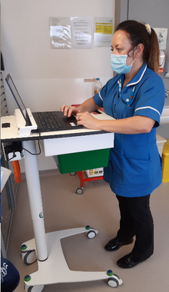
  Pioneering project team up for national award
  The team behind a pioneering project improving medicines safety has been shortlisted for a national HSJ Digital Award.
  The Electronic Prescribing and Medicines Administration (ePMA) team have been shortlisted in the Improving Medicines Management and Pharmacy through Digital category.
  The award recognises the team’s work in implementing ePMA across the Trust’s 57 mental health and learning disability wards. CNTW is one of the first mental health Trusts to take on this challenge.
  

  
  Psychiatrist lifts the lid on burnout in new book
  Dr Richard Duggins, consultant psychiatrist and psychotherapist at CNTW explores the growing challenge facing today’s workforce.
  His new book ‘Burnout-Free Working: An Expert Guide to Thriving in a Stressful Workplace’ builds on two decades of patient experiences, sharing what can tip people into burnout and how to deal with it.
  

  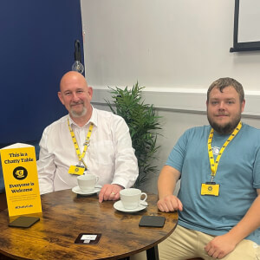
  Hope Haven and Kells café join forces with national scheme to reduce loneliness
  The Next Chapter Coffee Bar in Kells has become the first café in West Cumbria to join the Chatty Café Scheme, a nationwide initiative to reduce loneliness.
  The Chatty Café scheme aims to reduce social isolation by encouraging people to start conversations.
  Starting 27 June 2025, The Next Chapter Coffee Bar will host a Chatty Table every Friday from 10am – 12 noon, offering a welcoming space for people to connect.
  

Medical Development CPD events

CNTW’s Medical Development Team are delighted to offer three new CPD (Continuing Professional Development) events over the next few months which will cover:
- Gambling prevention and mental health
- Physical health in psychiatry
- Update on mental health services for primary care practitioners (this event is aimed at primary care practitioners and GPs)
An early bird rate is available until Thursday 31 July. If you would like more information or to book, please email MedDevelopment@cntw.nhs.uk

Work for us

We have a number of posts available across a range of specialities across Cumbria, Northumberland, Tyne and Wear.



